An Exploration of the Impacts of Economics and Culture on Healthcare at the Kibimba Hospital, Burundi, Africa

Erienne Ballard

Submitted in Partial Fulfillment of the Requirements for Graduation

from the Malone University Honors Program
Adviser: Rosanna Hess, Ph.D.
November 5, 2021

Abstract
Problem
Healthcare is impacted by both the socioeconomic status and cultural traditions, beliefs, and practices. I wanted to learn how these factors affect the healthcare nurses provide their patients as well as the ways that patients seek and receive care in a developing country like Burundi, Africa.
Purpose
The purpose of this research project was to explore the ways that economic and cultural aspects of Burundi impact the forms of healthcare.
Methodology
This research was a qualitative study conducted through a series of face-to-face, semi-structured interviews with healthcare providers Kibimba, Burundi, Africa. In addition, data was gathered during observations and participation in the surgical, maternity, and emergency departments. It was recorded in a surgical log and field journal and with photographs.
Results
Thirteen individuals participated, all of whom were Burundian. There were ten nurses, two doctors, and one lab technician. Two main themes emerged; First, the impact of economic status of the country and rural setting which impacted nursing roles, supplies, the effect of COVID-19, patients’ ability to seek care, and the government aid in covering costs. The second theme was on the impact of cultural differences on nursing care and patients’ response to care, which included the nursing values prioritized by the nurses, patriarchal and religious influences, traditional medicine, education in the community, and culture in health decisions.
Conclusion
The impact of economic status and cultural differences in developing countries such as Burundi can be seen in the nursing care and patients’ seeking and response to care. Economically, there are deficits in supplies and staffing that can affect the quality of care while patients living in poverty cannot afford to seek care at all. Cultural differences that may sway a patient’s seeking of treatment involve consultation of traditional medicine, the role of a nurse in a Burundian hospital, and the religious or cultural beliefs.

Acknowledgements
There are a multitude of people who have supported me throughout the past two years in this project. I would like to thank my parents, Jack and Lori Ballard, for their continued support –both academically and financially– throughout it all. This project’s trip to Burundi would not have been possible without the help and connections of Dr. Jacci Stuckey as well as the efforts of Rusty Savage and Matt Macy through Evangelical Friends Missions. My host in Burundi, Dr. Nahimana Elisée, and my translator, Joyce, helped me with my research in ways I couldn’t have imagined. To my thesis advisor, Dr. Rosanna Hess, I owe the world for putting up with the four IRB applications and ten different thesis ideas. To my thesis committee, Dr. Lora Wyss and Dr. Jay Case, I owe my gratitude. Others that I would like to briefly mention due to their involvement or support during this thesis: Heather Ballard, Ashlyn Doudna, Connie and Ken Olmstead, Holly Kibler, Stephanie Reagan, Mandi Kinsey, Karly Bruce, Phebe Swym, Kourtney Hunter, and Vy Hoang.

Contents
Chapter 1 – Background.……………………….………………………………………..10
Burundi.………………………….…………………………………...………….12
Geography.…………………….………………………………………....12 History.…………………….…………………………………………….13
Economic Status.…………………….…………………………………..14
Population Growth………………………………………………………15
Health Status.……………………………….…………………………....15
Traditional Medicine.……………………………………………..……...16
Kibimba Hospital.…………………….………………………………………….17
Summary………………….……………………….……………………………..19
Chapter 2 – Literature .……………………………….………………………………….20
Cultural Competence.……………………….…………………………………...21
History of Global Cultural Influences in Healthcare.…………………………....22
Importance of Healthcare Providers Recognizing Culture in Global Healthcare..23
Culture and Faith Effects on Healthcare.………………………………………...24
Nursing Considerations in Cultural Differences in Healthcare.………………....26
Nursing Values.……………………….………………………………….26
Nursing Education.……………………….……………………………...28
Summary………….……………………………….……………………………..28
Chapter 3 – Methodology.……………………….……………………………………….30
Study Design .……………………………….……………..…..………………30
Ethical Considerations.……………………….………….….….….…….30
Translator.……………………………………………….….….….…….30
Recruitment .……………………………….………….….….………….31
Interview Sites.………………………………………….….….………..32
Data Collection Process.…………………………..….….………………33
Sources of Data.…………………………………..……………………………..33
Interview Guide.…………………...…….………………………………33
Field Journal.……………………….……………………………………34
Surgery Log.……………………….……………………………………34
Photographs.……………………….…………………………………….35
Data Analysis.……………………….…………………………………………..35
Summary………………….……………………………….……………………..36
Chapter 4 – Findings.……………………….…………………………………………..37
Research Question.……………………….……………………………………...37
Participant Demographics.……………………….………………………………37
Hospital Background.……………………….…………………………………..37
Illnesses and Diseases Most Prevalent.…………………………………..37
Function and Schedule of the Hospital Staff.……………………………38
Public Perspective of the Hospital.……………………….……………...38
Themes.………….…………….……………………………….………………...39
Impact of Economic Status on Nursing Care and Patients’ Response to Care…..40
Nursing Care.…………………………………………...………...……...40
Deficiencies.………..………………………...………...………41
Nursing Role.………………………………...………...………..43
COVID-19’s Economic Impact.………………………………...44
Patients’ Seeking of and Response to Care.……………………………45
Poverty Prevents Patients from Seeking Care………..…………45
Government Aid for Maternity and Pediatric Patients.…………47
Insurance.……………………….……………………….48
Impact of Cultural Beliefs on Nursing Care and Patients’ Response to Care.…..48
Nursing Values.……………………….………………………………….48
Knowledge.……………………….……………………………...49
Trust…………………...…...………………………………….…50
Teamwork and Support.……………………….………………...50
Nursing Influence.……………………….……………………………….51
Patient Privacy in the Hospital……….……………...…………...51
Kibimba and Rural Burundi Considerations……….……………...…….52
Who Makes the Decision for Healthcare?……….………………52
Culture and Health Decisions……………………...……………53
Religious Influences……………….……...……………………..53
Traditional Medicine……………………...……………………..53
Education in the Community………...………………………….56
Summary…...…….……...……………………………………….57
Chapter 5 – Discussion……………….…………………………...…...………………58
Research Purpose Statement and Question ……………….…………..…...……58
Discussion of Findings ……………….……………...………..………………...58
Socio Economic Impact……………….……...……..…………………...58
Cultural Impact……………….……...……………………….………….61
Limitations of this Project……………...…………….…………………………..62
Language Barrier……………….……...………………………………...62
Situational Difficulties……………….……...……………………...……63
Importance of this Study……………….………………………………………...64
Recommendations……………….……...………………………………….…… 66
References…………………….…………………….…………………………………....67
Appendices.………………………….…………………………….……………………..71
A – Approval Letter from Malone University Human Research Committee……71
B – Approval Letter from Kibimba ….…………………………………………72
C – Consent Form (English)………….……………………….…………………73
D – Consent Form (French)………….……………………….………………….75
E – Interview Guide………………….……………………….…………………77
F – Surgical Log………………….……………………….……………………...79
G – Participant Demographics.……………………….………………………….87
List of Tables
1 Table of Demographics……………….……...…………………………82
2 Nursing Value Rankings………………...………...…………………....49

List of Figures
1 Entrance of Kibimba Hospital……………….…….……………...……11
2 Guest House of Kibimba Hospital……………….…….………………12
3 Map of Burundi……………….…….…………………….……………13
4 Map of Kibimba Region……………….…………………………..…..13
5 Kibimba Hospital……………….……………………………………...18

Chapter One – Background
The background for my choice of this research project began when I was living in Kenya at age twelve, as well as from my mother’s master’s thesis, which evaluated culture’s impacts on Kenyan nursing students’ education in regards to critical thinking. I believe that cultural competency and awareness is crucial for any individual in the healthcare field. The profession of nursing calls for nurses to demonstrate cultural humility and be fully present in their work. In learning about a developing country’s healthcare system, I would have the opportunity to understand another culture in addition to gaining insight into the ways that a hospital in another part of the world functions in comparison to ones I know in the United States. Therefore the purpose of this research project was to explore the ways that the economic and cultural aspects of the country impact the forms of healthcare that are available and the routines of the hospitals that are there. It is important to evaluate the ways that a hospital adjusts to the low amounts of supplies and location. More specifically, this research’s purpose was to, first, understand how Burundi hospitals adjust to the economic drawbacks they may have, as well as to demonstrate ways that healthcare – nursing care in particular – in a developing country is different from the States to both medical professionals and nonmedical individuals.
My original plan was to go to Guatemala for six weeks in May 2020 to Hospital Shalom in San Benito. Unfortunately, the global pandemic related to COVID-19 occurred in March of that year and all international travel ceased. As the pandemic continued, another planned trip to Guatemala was cancelled again in March 2021. Another country would have to be the focus of my project. From March 2021 until the beginning of July 2021 I explored options in six different countries, multiple organizations locally, rewrote the focus of my thesis three times, and submitted applications for two visas until a connection led to Burundi, Africa.
I arrived in Burundi in mid-July, 2021. My lodging was in the Kibimba Hospital guest house, about 100 meters from the Kibimba Hospital (Figure 1), and 400 meters from the house of the president of the country which was continually surrounded by soldiers. All the food I ate in the guest house (Figure 2) was prepared by the house cook. I attended three different churches during my stay, all in the Evangelical Friends Church (EFC) denomination. The president of Burundi was in attendance in one, for the dedication of the church. I attended another church in Bujumbura, and the third one near the Kibimba Hospital. I also spent two weekends touring Bujumbura, the economic capital of the country. I returned to the United States in mid-August, 2021.
Figure 1. Entrance of Kibimba Hospital
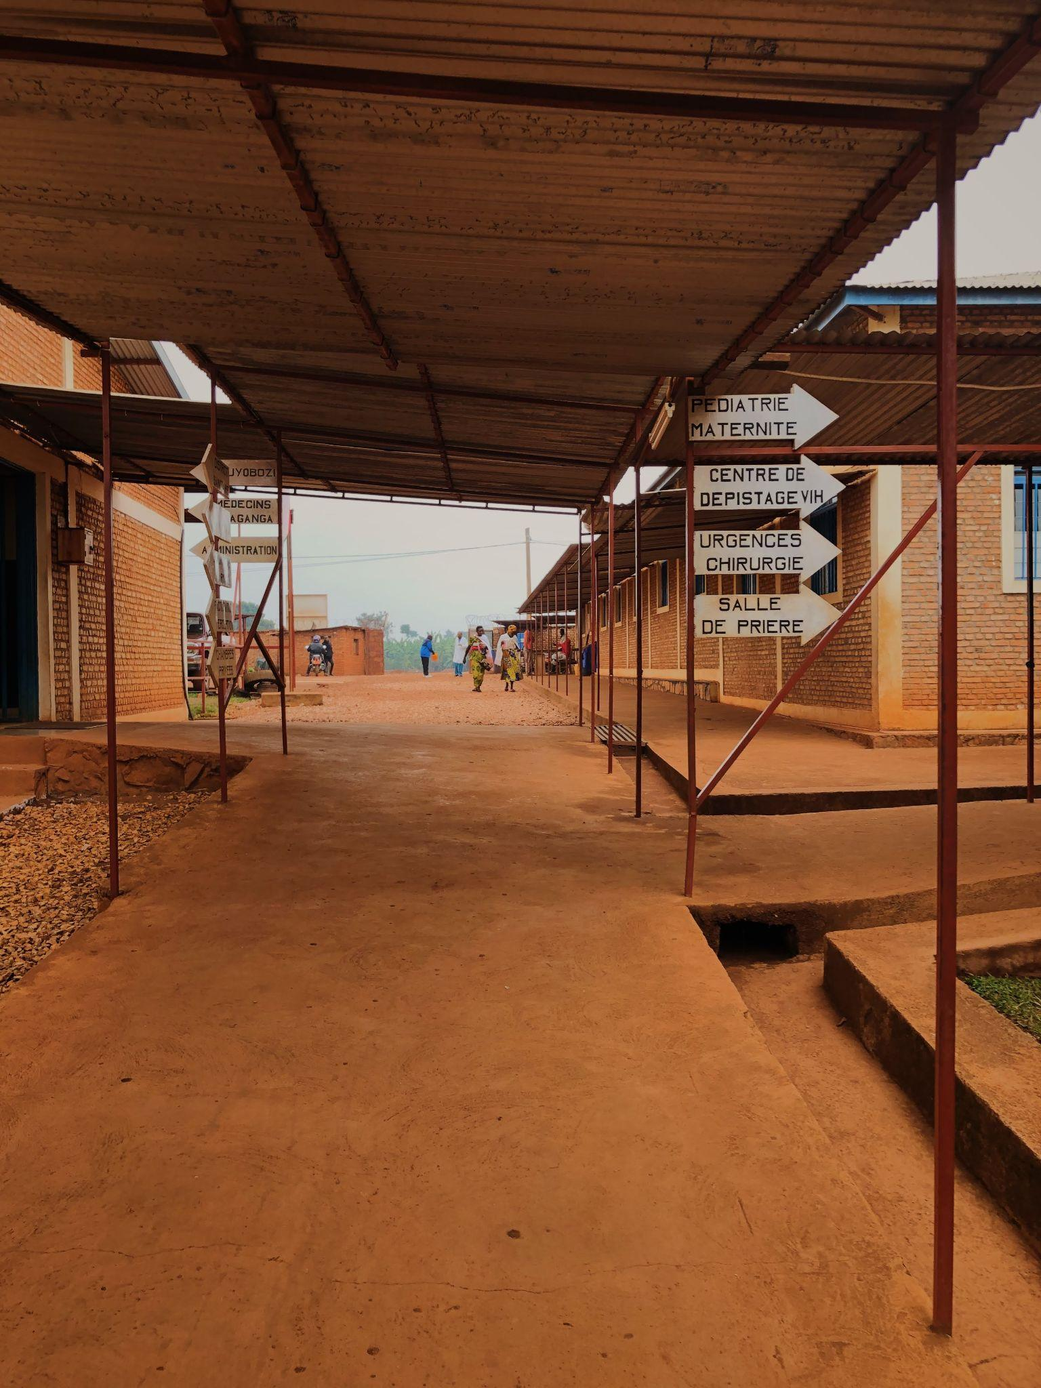
This is the main entrance of Kibimba Hospital. 2021.
Figure 2. Guest House of Kibimba Hospital
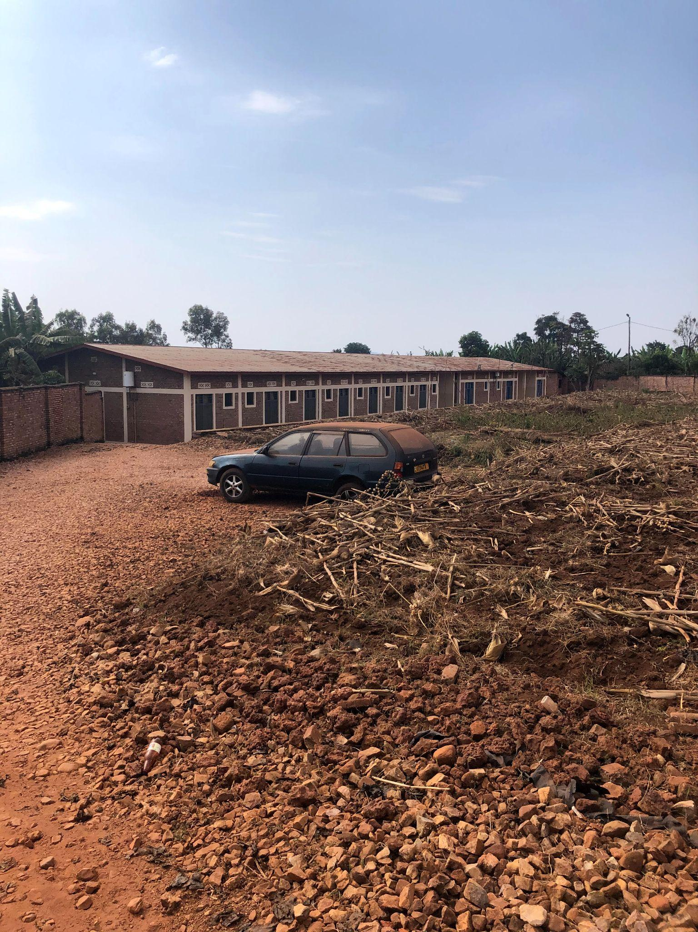
Photo of the guest house I stayed in during my stay. 2021.
Burundi
Geography
Burundi is a small country in the eastern central part of Africa, about the size of the U.S. state of Maryland. It is bordered by Tanzania, Democratic Republic of Congo, Rwanda, and borders Lake Tanganyika. (Figure 3). The hospital in which I collected data for this research is located in the more central provinces of the country. Kibimba is located on the border of three of these provinces: “Kibimba is a mountain located in the Kabaga area, commune Giheta in the province of Gitega… located at the border of two provinces, Muramya and Mwaro” (Ngendakumana, 2021). Its location is 75 kilometers from Bujumbura and 23 kilometers from Gitega on the main road RD2 that links these two cities. (Figure 4) These cities are vital to the country’s function as Bujumbura is the economic capital and Gitega, the political capital.
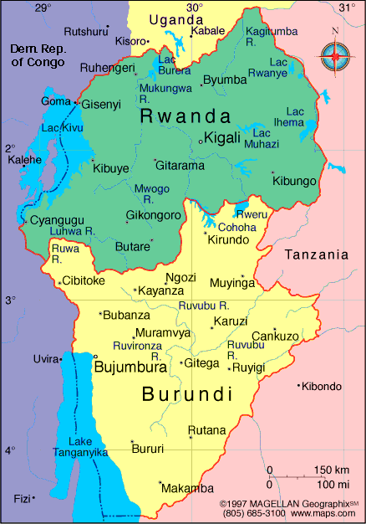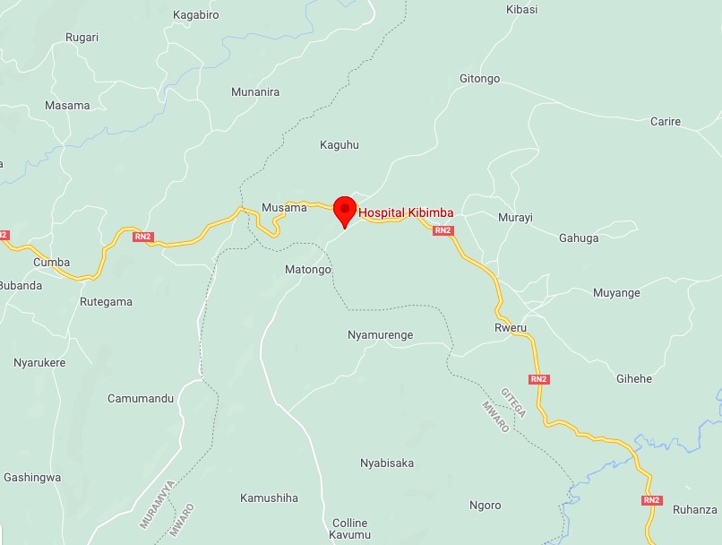
Figure 3. Map of Burundi Figure 4. Map of Kibimba Region
History
The history of Burundi has been complicated over the past two centuries. In its precolonial state it was primarily populated by Twa people, followed by the Hutu, and finally taken over by a Tutsi monarchy. Those populating this area during the nineteenth century saw Europeans enter. Burundi was first taken over by Germany but after the First World War it was given to Belgium. As race was a powerful component in power holding, the Tutsi remained in a ruling position as they were lighter in skin tone and shared more physical characteristics to Europeans than the Hutus did. Following the Second World War, Burundi successfully began its campaign for independence and started as a constitutional monarchy in 1959 (Kahan Eggers & Lemarchand, 2019). Through 1961 until 1993 changes within the government consisted of the gain of independence from Belgium in 1962, two Tusti dominant Republics that saw massacres of the Hutu people and, with the Third Republic, the assassination of a Hutu president in 1993 that sent the country into a civil war. This civil war lasted until 2005 (Kahan Eggers & Lemarchand, 2019). There has been a considerable decrease in the tension and conflict over the last decade but the country is still in a position of recovery.
Economic Status
The impact of these disputes has had a remaining influence on the economic status of the country. A lasting impact of the war was upon the country’s international trade, need for foreign aid, and the continuation of low levels of income in the population. As Burundi is mainly an agricultural country, their exports consist usually of coffee, cotton, and tea (Kahan Eggers & Lemarchand, 2019). According to the World Food Programme (2019), Burundi is a country of extreme poverty; there is over 70% of the population who are living at a level of poverty. Its Global Domestic Product is ranked one of the lowest in the world per capita. In addition to the lasting effects of the civil war, the conflicts within the Democratic Republic of Congo and the influx of its refugees, the low levels of education, and the residence of 90% of the population in rural areas, add to the economic challenges for this country. Finally, to add to this, the pandemic of COVID-19 has limited trade with other countries with closed borders, resulting in the population relying on their own agricultural efforts more than before (World Food Programme, 2019).

Population Growth
Burundi’s population was about 11.89 million in 2020, but with a projected population growth percentage of 3.16%, it is predicted that today the population is over 12 million and will exceed 500 million by 2098. This is due to the high birth rate (over one thousand per day) and high fertility level with about 5.4 births per mother. The population density of this country is about 1,076.6 people per square mile with an average age of 17 years old (World Population Review, n.d.).
Health Status
The World Food Programme also highlights the impact of Burundi’s critical socioeconomic state on the country’s health. The population sees food poverty that adds to health issues such as malnutrition and infection. There is difficulty accessing clean water in many places, especially as the country is primarily rurally populated. There is difficulty for many in the community to access education or healthcare which increases the poverty level and negatively influences the population’s health (World Food Programme, 2019).
The availability of health services in the country has increased substantially over the years from 38.2% of the population being reached in 2010 to an estimated 49.9% in 2019 (Institute for Health Metrics and Evaluation (IHME), 2015). The main causes of death in the country are diarrheal diseases, neonatal disorders, tuberculosis, malaria, and lower respiratory tract infections. The rate of child mortality under five years of age has decreased from 178.7 per 1,000 in 1990 to 63.7 in 2019. The presence of Acquired Immunodeficiency Syndrome and Human Immunodeficiency Virus is in the country but is ranked tenth out of the leading causes of death and disability. The leading risk factors for death or disability are first, malnutrition, followed by WaSH (water, sanitation, and hygiene), air pollution, and alcohol intake, respectively (IHME, 2015).
After the war ended in 2006, the country found itself working towards promoting health and ensuring a decrease in the mortality rates in both the maternal and pediatric populations: “Burundi’s government realized it likely would not reach the United Nation Millennium Development Goals related to reducing maternal and child mortality by the 2015 deadline. To speed up the progress, the government declared all medical care free for pregnant women and children under five” (Burundi: Investing in Safer Births, 2012). There remains a lack of physicians, however, as “Training of medical doctors is very difficult as Burundi has to depend on the neighbouring countries for medical education” (WHO | Burundi, n.d.).
Traditional Medicine
In addition to the use of biomedical treatments for illnesses and diseases, Burundians often consult traditional healers for treatment. A study completed on medicinal herbs and practices used and observed found that “… more than 80% of the population mostly resorts to traditional herbal medicines, sometimes combined with animal and mineral substances, whether for daily cares or emergency situations” (Ngezahayo et al., 2015, p. 339). This practice is mainly held by the older individuals in the population, but remains in the country (Ngezahayo et al., 2015). For example, with the recent COVID-19 pandemic, traditional medicine has been making more of a comeback as many Burundians have turned to traditional medicine, mixing eucalyptus leaves, ginger, and other powders in order to protect themselves from contracting respiratory diseases, including the coronavirus. There are other recipes and powder mixtures that traditional healers may offer to prevent infection (Muco, 2020).
Kibimba Hospital
Kibimba Hospital has a rich history of missionaries, churches, and Burundian medical professionals who kept the hospital running during the many crises that occurred over the years. The history of Kibimba is described by the doctors and pastors who ran the hospital over the last several decades within a detailed documentary by Daniel Ngendakumana, the youngest brother of Dr. Nahimana Elisée. In this documentary, Reverend Pastor and Doctor David Niyonzima, one of Kibimba Evangelical Friend Church’s leaders, recounts the beginning of the hospital with the church’s origin. Kibimba is associated with the Evangelical Friends Church (EFC), which was started in Burundi by an American missionary couple, Arthur and Edna Chilson, with their daughter Rachel. They came from their original mission calling in Kenya and settled on Kibimba mountain.
Retired Evangelical Friends Mission (EFM) missionary Doris Ferguson gave an account of the four objectives that the missionaries had on the mountain: (1) to preach and spread the gospel; (2) to build schools and increase education; (3) to help the sick by building hospitals; and (4) to train the population how to build modern houses and to perform trade jobs. Its initial capacity was limited with the ability to only treat ten patients at a time in traditional structures. The hospital was built in 1949. Doris Ferguson recounts that the original layout was two houses with rooms including an operating theater, office, a spot to sterilize tools with charcoal, and a laboratory with a pharmacy. Today the hospital is five times what it was in the 1950s but still has the original buildings (Ngendakumana, 2021). See Figure 5.
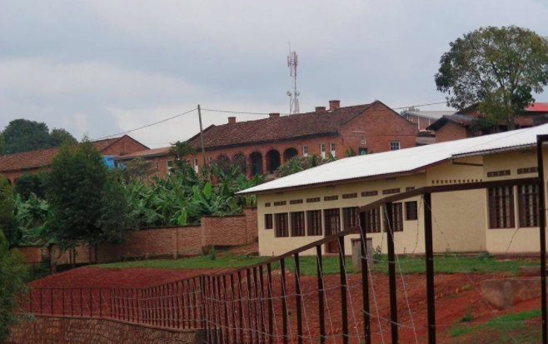
Figure 5. Kibimba Hospital. The original building, now the laboratory, is the brick building in the background.
The hospital had many directors over the years with the government changes, wars, and missionary presence. The first director was Dr. Perry Rawson from the hospital’s beginning in 1946 until 1972, a twenty-five year management. Other missionaries came during this time to assist Dr. Rawson, and when he left in 1972, expatriate nurses –such as Doris Ferguson– ran the hospital. Political strife in 1984 forced the missionaries to flee the country and the Burundians were left to run the hospital on their own. During this time several Burundian nurses ran the hospital as well as two doctors sent by the government, a Dr. Hermenegilde and another physician from Rwanda, who were relieved temporarily by Nahimana Elisée. Dr. Elisée’s schooling was paid for by the Friends Church under the condition that he would return to work in the Kibimba Hospital. He worked from 1990 until 1993.
The start of the civil war in 1993 resulted in nearly every employee fleeing which left three nurses to run Kibimba Hospital. This was an immense responsibility as Kibimba was –and continues to be– one of the main hospitals in its area, in its geographical position between provinces. From 1996 until 2006, pastors and government-appointed doctors ran the hospital. Even during this war period the hospital remained open. In 2006, as the war came to an end, Dr. Elisée returned from schooling in Ivory Coast and Madagascar to take over as director and lead physician. He is still managing the Hospital as the director, has become well known and respected within Burundi, and has received many awards for his medical interventions.
Summary
I went to Kibimba Hospital in Burundi, Africa with Evangelical Friends Missions in the summer of 2021. The Hospital has a long history dating back to 1934 when the first missionaries came to establish the Friends Church. It remained open during the war years of 1993 through 2006 and is now one of the main hospitals in its area, led by Dr. Nahimana Elisée, a renowned general surgeon. Kibimba Hospital’s presence is crucial for the community as Burundi has a high percentage of people living in poverty. This country's health has been impacted by the cultural traditions of indigenous health and its economic status, especially in rural areas.

Chapter Two – Literature
Burundi, by nearly every account, is considered a developing country. The poverty levels are some of the greatest in the world as Burundi continues to recover from the civil war that ended in 2006. This country’s socioeconomic status as well as its cultural history, practices, and beliefs have a direct impact on the healthcare that is available together with the quality and type of care that is offered.
Healthcare itself is as diverse as the world. Every continent, country, and community each introduce unique elements to the routines and practices of medicine. This can be said about Africa, Burundi, and the community of Kibimba. The practices that may be present can vary based on the beliefs and morals of different cultures within each of these levels, which can span from herbal practices, traditional medicine, and witchcraft to self-treatment or utilization of clinics and hospitals. Each unique approach through cultural beliefs can pose a position of intercultural practice. For someone to be a healthcare professional with the responsibility of caring or saving another person, the support of trust, morals, and education are needed as well as ensuring the capability to recognize the differences in one’s own beliefs from patients and healthcare facilities. Upholding the consideration and attention of the cultural elements that may determine the route of treatment is a task that should be routinely evaluated and included in the nursing profession. In the scope of cross-cultural care, both in the United States and within international care of hospitals such as Kibimba, being receptive to learning as well as sincerely respecting the values and teachings of another country is one great step towards cultural competency, understanding, respect, and appropriate practice.
Cultural Competence
Nursing care should be approached with a cultural competence and desire, as well as acknowledging the impact of poverty on opportunities for healthcare, so that they may provide the best treatment for patients. Understanding not only what it means to have cultural desire, but in understanding the history of the economic gap affecting healthcare in addition to the impact of faith and culture on health and care, promotes competency and beneficial care for patients in cross-cultural settings such as Burundi.
Cultural competence is the combination of one’s awareness, knowledge, skills and encounters of and with another culture (Foronda et al., 2016). It is the ability to approach diverse cultures within a field of work, such as nursing, and to provide the best and most appropriate form of care and respect. Furthermore, cultural desire is the spiritual aspect that comes with drawing near to others. “Cultural desire becomes the motivation of the nurse to want-to engage in the process of becoming culturally competent” (Campinha-Bacote, 2003, p. 21). Nurses are called to approach nursing and work in a manner that is driven by the want and willingness to not only serve others, but to engage in activities and learning opportunities that promote the understanding of other cultures (Campinha-Bacote, 2003). Within that, it is necessary to demonstrate cultural humility. This is defined as a cognizant and mindful state of self-examination of one’s own beliefs and the differences that may present with an encounter with another culture (Foronda et al., 2016). In practicing nursing in a cross-cultural setting, one must have an awareness of one’s own cultural beliefs to recognize the differences with the other.

History of Global Cultural Influences in Healthcare
The effects of cultural and economic divide can be seen across the globe and throughout history. The phenomenon of inequality in the presentation and execution of adequate healthcare across the world’s societies is not new. One writer put it this way. “This can be seen within the divide of the working class and the upper class of the nineteenth century when there was a noticeable difference in the ailments suffered. This dissimilarity came to be associated with those with a lower income and altered lifestyle factors, from working conditions to housing situations. It was at this time when they realized the focus of medicine should shift from changing the individual to that of changing the society” (Gibbons, 2005, p. 1). This realization moved the focus of medical research from fixing one person to looking at a society as a whole. Richard M. Titmuss worked in social policies in Britain in the 1950s and much of what he focused on in his work was the health and welfare of the community (London School of Economics and Political Science, n.d.). He said,“... higher income groups know how to make better use of the service; they tend to receive more specialist attention; occupy more of the beds in better equipped and staffed hospitals; receive more elective surgery; have better maternal care, and are more likely to get psychiatric help and psychotherapy than low-income groups particularly the unskilled” (Tudor Hart, 1971). Cultures can develop from geographical locations –rural and urban– in addition to economic classes. Looking into the cultural divide in the healthcare system on the global scale, racism and economic classes have existed for generations, which has led to the unequal care of the sick, neglecting the poor. Mission organizations may have contributed to this unequal distribution as early missionaries were beginning the process of understanding cultural divides in addition to settling in new places without the medical tools that they had learned to use in schooling. In the twentieth century Dr. Ernie Steury found difficulties with ensuring that the hospital he was at was stocked with adequate supplies or the correct equipment. An example of this problem is recorded in Miracle at Tenwek, the biography about his mission work in Kenya in the 1960s, including lack of diagnostic equipment or enough medicine (Lewis, 2007). Dr. Steury’s experience with this is one of many instances globally that have occurred and continue to this day. This trend of an economic gap has been a continuous menace for healthcare of all those who are in need of it, especially in the developing world. For example, in South Africa, “The socio-economically disadvantaged are more likely to experience poor health status, disability, the simultaneous occurrence of more than one condition/disease (multi-morbidity) and are less likely to use inpatient care” (Gordon et al., 2020, p.1).
Importance of Healthcare Providers Recognizing Culture in Global Healthcare
This gap in global healthcare has a continuous presence. Though in the twenty-first century respect for other cultures in the social setting is a popular movement, this may be harder to see in healthcare. Health care providers may not understand the practices that other cultures utilize for their health, as those practices may not easily be categorized into the Western or scientific medical realms. In some circumstances of treatment, it can seem that science has a specific method to treat ailments but accepting the diversity in beliefs and patient decisions can be difficult. To date, the gap between culture, ethnicity, and economics can be seen to “include differences in geography, lack of access to adequate health coverage, communication difficulties between patient and provider, cultural barriers, provider stereotyping, and lack of access to providers” thus inhibiting care (Crowley, 2010, p. 2). All of these factors keep healthcare providers from accessing patients or patients from accessing or accepting healthcare. Historically there have been movements towards bridging the divide, but this inequity is still present today (Crowley, 2010).
Culture and Faith Effects on Healthcare
An additional element that heavily impacts healthcare is religious faith. Faith in the medical field can differentiate between religion and spirituality and can be affected by different interpretations. As an organized practice of beliefs, religion has a set of rules that determines what adherents are allowed to do regarding their bodies. For example, in the Jehovah's Witnesses community “blood in any form and agent in which blood is an ingredient are not acceptable” ((Andrews & Boyle, 1999/2008, p. 391). This is a practice that has been ruled by the Watch Tower Bible and Tract Society of Jehovah’s Witnesses and must be legally recognized in most countries, including the United States (Woolley, 2005). Disrespecting this belief is denying that individual their religious rights. Christian Scientists do not use blood, medications, immunizations, or accept transplants (Andrews & Boyle, 1999/2008). Islamic women may decline male physicians to prevent being seen by a man who is not their husband (Attum & Shamoon, 2019), and Judaism may avoid genetic engineering in prenatal care (Rosner, 1998).
Cultural beliefs have been known to alter the preferred method of care for patients. Arab families may deny or cover up family mental illnesses as it is a greatly feared condition by Arabs and Chinese may believe that eating body parts of animals will cure the same part of the individual or that blood draws will affect the body negatively (Dixon, 2009). These beliefs can alter how patients prefer to be treated and can affect their recovery. These beliefs are passed through the generations. One example of this is Dr. Ernie Steury, the doctor mentioned previously, and his work in Africa. He had difficulties not only because he lacked equipment and supplies in the hospital but because he also lacked understanding of the beliefs of the patients he was treating. He found it hard to get women, especially maternity patients, to take control of their care, as the cultural expectation was to allow men to make every decision for their wives. This continues in Burundi today.
Burundi itself follows a traditional model of the family with the father at the head of the household. “It is a patrilineal culture in which man incarnates authority within the household, makes crucial decisions, and provides livelihood to the members of the household” (Basse et al., 2017, p. 40). As the man is in charge of the family, decisions regarding lifestyle, food, finances, and health are ultimately up to him. This is an important cultural consideration for those of other cultures caring for patients, especially women.
In addition to gender roles, Burundi’s population has an overwhelming majority of Christians, both Catholic and Protestant. The United States Department of State estimated in their 2020 religious freedom report that sixty-two percent of the citizens identify as Catholic, followed by 21% who affiliate with various Protestant denominations (“2020 Report”, 2021). As denominations practice different rituals and traditions, there may be discrepancies between them and the way that they worship, gather, practice faith, and accept care.
As Western medicine has increased its presence in Africa, the education and acceptance of its healthcare practices have become more abundant, accessible, and sought after. Even with biomedical care, however, there remain individuals who seek care through indigenous healers. Many Burundians culturally choose indigenous medicine or witchcraft for healthcare. This cultural pull towards the utilization of some biomedical practices in addition to indigenous healers might be related to distrust of Western medicine, the tendency to stick with traditional healing after the civil war strife, or because of the insufficiency of the existing public health centers (Falisse et al., 2018).
It is important for those who want to go abroad within the medical field to respect that the various cultures they may encounter have beliefs that have been around for generations and may greatly affect the ways that they are able to care for their patients, whether it be herb and drug interactions or patient refusal of care. This has been an obstacle for healthcare missionaries traveling to foreign countries with goals of healing, as they may not understand why a culture’s strong beliefs may be more compelling to the patient than science.
Nursing Considerations in Cultural Differences in Healthcare
Nursing Values
Those who are interested in cross-cultural healthcare need to develop an understanding of the importance to uphold other cultures’ practices; when traveling to another country or alternative culture, it is important to understand the set of values and beliefs that are upheld in the healthcare practices in the new culture. Comprehension of those values and their meaning for patient care allows for effective professional collaboration. Doctors and nurses should not go into the situation with the strict belief that their set hierarchy of values is superior and it is their responsibility to alter the principles of those they are helping. Medical volunteers should approach the situation with a willingness to learn and to help develop that culture’s medical practices within its hierarchy of values and ethics. The ranking of values for those working in the medical field can be attributed to the prioritization of research, care concerning the individual, care of the population, or advancing in the professional setting (Alfred et. al., 2013, p. 924). In other words, nursing values also have an influence on the care that someone gives. The order of one’s prioritization can be related to the methods of nursing they practice (Snellman & Gedda, 2012).
This hierarchy is not only different throughout the world at the national level but may also be different at the institutional level. Alfred and associates (2013) examined cultural care priorities of students from two different continents/countries Taiwan and the United States. These values included: “Collectivist cultural traditions: Advancing the profession through active involvement in health-related activities, participating in activities of the professional nursing associations, seeking additional education to update knowledge and skills, and safeguarding the patient’s right to privacy… Individualist cultural tradition: acting as a patient advocate, maintaining competency in the area of practice, managing in ongoing self-evaluation, and assuming responsibility for meeting health needs of the culturally diverse population” (Alfred et. al., 2013, p. 923). They concluded that “nurses who are educated in different countries with diverse cultural perspectives do affirm the same core values. However, the differences ascribed to the priority of these core values are distinctive and mirror the cultural values of the students” (Alfred et. al., 2013, p. 923). Nursing differs on the basis of cultural upbringing and education.
Nursing Education
The principles of nursing education may be the same universally, but the importance of the elements varies between cultures. As mentioned previously, the United States students in Alfred’s study considered individual health as the priority to focus on while their Taiwanese peers were more concentrated on the community aspect of health. In the case that an American student was to treat either a Taiwanese patient or in the community, they would need to understand the importance of community rather than their personal preference of individual care. This demonstrates the need for any healthcare professional to grasp the ideologies of the country they are visiting to respect and benefit the community, culture, and the patient.
Summary
Cross-cultural nursing practice requires both cultural humility and cultural desire, both representing the knowledge, skills, encounters, and awareness that a healthcare professional should have. The history of cultural and economic gaps in medical care is extensive but has been on a more positive turn in the present as more healthcare providers are becoming self-aware of their own cultures. In taking all of this into consideration, looking at developing countries and the impoverished populations of the world, the research question to guide this project in Burundi was: How does the economic status of and the cultural beliefs and practices of Burundians impact nursing care of patients in the hospital setting?

Chapter Three – Methodology
Study Design
A qualitative research design was used for this study. The primary forms of data collection were from interviews, observations, and experiences within my month-long stay in Kibimba, Burundi, Africa in July and August 2021.
Ethical Considerations
The Human Research Committee of Malone University approved this study (Appendix A) after receiving a letter of approval for my study, observation, and participation in Kibimba Hospital from the head doctor, Dr. Nahimana Elisée (Appendix B). Every participant received a copy of a consent form in French, or English if they wanted, (Appendix C and D) to keep, was given the opportunity for questions both at the beginning and the end of the interview, and signed a copy for storage at Malone University School of Nursing. .
Translator
As the language that the interviews were conducted in included a combination of French and Kirundi, the two official languages of Burundi, I needed a translator to assist me. Joyce, a member of the Evangelical Friends Church that Kibimba Hospital is associated with, volunteered to accompany me during my stay. Joyce spoke French and Kirundi, as they are the national languages, as well as English, which she studied in school, and some Swahili, an African language spoken in East Africa that is used more in Bujumbura than the rural areas. She had travelled to England for an international church gathering and was familiar with the language differences. In the past, she assisted missionaries and other foreigners in the church setting. After the research was completed, and without her prior knowledge, I financially compensated her for her time and travel from Bujumbura on the weekends. As Joyce spoke both languages fluently, she was able to translate all interviews. There were, however, three interviews that were completely or partially conducted in English, but Joyce remained present for any mistranslations between them and myself. Some challenges, such as misunderstandings of medications or surgical terms, arose during the interviews as Joyce was not a healthcare professional. There were many of these times where we were able to find a shared understanding to simplify the question for translation. For example, there were a few instances with miscommunications regarding the term “vital signs”. I learned to ask questions by listing the various vital signs –blood pressure, heart rate, temperature, and respirations– instead of generalizing them. We found that this not only was easier for her to translate but better for the interviewees to answer. Another example was her understanding of the term for those who help nurses by doing some nursing activities without formal education, as they had learned on the job. I explained the concept of a nursing technician in the United States and she began to translate ‘helper’ as ‘tech’ to help me differentiate between those who were hired in the hospital for cleaning or assisting the nurses.
Recruitment
The participants who were recruited for interviews had to meet certain criteria. They needed to have worked at Kibimba at some point in their career as well as to currently be working in the Burundi healthcare system. They had to be from Burundi or a bordering country such as Rwanda, Democratic Republic of Congo, Tanzania, or Zambia –which borders Lake Tanganyika, where international trade takes place. All participants had to have attended secondary school and university, graduating with some type of science or medical degree.
The recruitment process was coordinated by Joyce and executed by the nursing chief, Jerome. Joyce shared with him the inclusion criteria as guidelines for the selection of participants, and provided him with copies of the consent forms to give to those selected. Jerome selected the interviewees based on their availability, area of service, performance in the workplace, and their willingness to participate. I was not directly involved in the recruitment process due to language barriers and my unfamiliarity with the staff and schedules.
Interview Sites
The majority of the interviews took place in the guest house, which was a 100 meter walk from the hospital. Interviewees were invited to come to the dining room during their breaks or after work and were interviewed in a controlled space. There were rarely distractions and the only other person in the guest house was the hospital cook, who took care to be quiet and avoided coming into the room unless he was getting food from the refrigerator to prepare meals. One interview took place in the hospital health clinic in the Family Planning/Prenatal care office for the convenience of the interviewee. The other interview which did not take place in the guest house was set in Bujumbura, in the translator, Joyce’s office at Rohero church. This interview took place outside of Kibimba as I joined a weekend trip to the city with Dr. Elisée and Joyce. The doctor who was interviewed there was also visiting the city and the interview was scheduled there out of convenience for both of us.
Data Collection Process
All interviewees consented to participate and to be audio-recorded. All interviews were audio-recorded on iPhone VoiceMemos and on an MP3 device. Immediately following each interview, recordings were downloaded onto a laptop from the MP3, a copy was made in MP3 format to my iTunes library, and they were deleted from the MP3 device in order to allow for adequate storage for following interviews. Both the laptop and phone are password protected and I am the only one with access to these devices. I transcribed each audio-recorded interview upon my return to the United States.
Sources of Data
I collected data from several sources: interviews, notes in field journals, observations, and photos.
Interview Guide
Interviews were conducted using a set of questions, summarized below, as well as probing questions that I added while I collected data. The guide was developed based on an interview and demographic guide in the article, The Experiences of Mexican Americans Receiving Professional Nursing Care: An Ethnonursing Study (Zoucha, 1998, p.42-45). The entire Interview Guide is found in Appendix E. The main questions are listed here.
- What are the illnesses and diseases you see most in your department?
- How do Burundians traditionally care for their sick?
- Who in the home makes the decision for hospital care?
- How is patient privacy demonstrated at Kibimba?
- What is the public perspective of the hospital?
- What was the impact of COVID-19 on your department?
I also adapted the six nursing values –responsibility, trust, nearness, sympathy, knowledge, and support– from Alfred and associates (2013) study with Tawiainese and American nursing students. Interviewees were given liberty to determine the definition of these words for themselves before ranking.
Field Journal
I wrote about my daily life in a field journal/notebook. As I was the only American in the province, all encounters were with someone from another culture. Also included in the journal were the conversations I had with the locals such as my translator, Joyce, the nursing students I worked alongside in the emergency department, the nurses that I assisted in the maternity department, and the doctors that joined me for dinner and church.
Surgery Log
I spent the most time observing and participating in the operating room as two of the doctors at Kibimba, Dr. Elisée and Dr. Lot spoke English and I did not need a translator with me. I was in the operating room for 58 surgeries in my four weeks at Kibimba. I assisted in 23 surgeries and observed 35. At the end of each day, I recorded my thoughts, observations, feelings, and actions in the surgery into a surgical log (Appendix F) which I incorporated into my field journal at the end of my trip.
Photographs
I was encouraged by Dr. Elisée, and many other staff members, to take photographs. I had also received ethical approval prior to travelling. I did my best to remain culturally sensitive to the most appropriate times for photographs and to avoid getting patients’ faces in them. I was permitted to take pictures and record videos of the surgeries I observed. On my final assist on a hernia repair, one of the staff members recorded a video of me as the first assistant. I was able to take pictures of the Hospital grounds but was unable to take them in the pediatric unit or the emergency department; I did not feel it appropriate to take pictures with the number of patients that were present and the work that was being done at the time.
Data Analysis
Upon returning home to the United States, several days were spent listening to the recordings and using Google Docs to type or use speech-to-text to transcribe and print the interviews. Recordings were listened to closely and transcribed as well as possible. When completed, the thirteen of them were printed and read over several times.
Themes emerged during the multiple readings. I highlighted key words and phrases in three different colors in addition to scribing notes in the margins. This is a form of constant comparison, a method used in qualitative research. This form of analysis allowed for editing to occur during the initial process; for the purpose of fine tuning the focus based on the research purpose statement and research question. Once the final flowchart was completed on the white board, I took pictures of it, then copied it onto a paper and typed into an outline. Following the themes from the interviews, I scoured my field notes for additional similarities from the observations I had made.
Each participant was given a pseudonym. Pseudonyms are used in descriptions and quotations in Chapter Four.
Summary
This research was a qualitative study conducted through a series of face-to-face, semi-structured interviews with healthcare providers Kibimba, Burundi, Africa with the assistance of a translator through Evangelical Friends Church. In addition, data was gathered during observations and participation in the surgical, maternity, and emergency departments. It was recorded in a surgical log and field journal and with photographs.

Chapter Four – Findings
Research Question
How does the economic status and the cultural beliefs and practices of Burundians impact nursing care of patients in the hospital setting?
Participant Demographics
Thirteen individuals agreed to participate. This included ten nurses of the 45 employed by Kibimba (22%), one doctor of the five employed by Kibimba (20%), one doctor from another clinic who had worked at Kibimba in the beginning of his career, and one laboratory technician out of the five employed by Kibimba (20%). Of the participants, 77% were nurses, 15% were doctors, and 8% worked in the laboratory. All participants were Burundian, ten were married, and their average age was 37. In regards to time spent working in their profession, the average was 8.7 years, and the average time spent working in Kibimba was 5.4 years. Only one of the thirteen participants was Catholic, the rest identified as Protestant –69% of whom associated themselves with the Evangelical Friends Church, the church with which the hospital is affiliated. All demographics are listed in the table in Appendix G.
Hospital Background
Illnesses and Diseases Most Prevalent
According to every interviewee, malaria is the leading cause of hospital visits to Kibimba and the surrounding clinics. Other common ailments that were mentioned included infections –spanning from bacterial to viral– , intestinal infections, hepatitis, osteomyelitis, sexually transmitted infections, urinary tract infections, tuberculosis, and typhoid. Many of the symptoms seen in the hospital include diarrhea, vomiting, and coughing. Noncommunicable diseases within the community included hypertension, diabetes, asthma, and renal ailments.
Function and Schedule of the Hospital Staff
The first thing for a nurse to attend when they come to work in the mornings is staff morning devotions. This is a time for the nurses, technicians, and doctors to come together and sing hymns, listen to a devotional, have announcements, and for meetings, if applicable. In pediatrics, there is one night shift nurse to care for the patients. In maternity, there may be two or three working during the night, but they tend to be the men in the department as the female nurses are mothers and have to return home to care for their children. Additionally, in maternity, there were several nurses on their maternity leave, which is three months split between the prenatal stages and the postpartum time. Scheduling nurses is the duty of the nurse overseeing the department. This schedule is then sent to the chief nurse to be approved.
Public Perspective of the Hospital.
The perspective of the public when it comes to the status of Kibimba Hospital is positive. The community is very aware of the clinic and many people are proud of its presence in Kibimba. Since it is on the border of Moranga, Gitega, and Morano provinces, many people come to it. In addition to its geographical location, Dr. Elisée is a very well known surgeon and people will come to the hospital for his treatment.
“It has been here, it has been here under the church which is a demonstration. It is ruled by the, I can say it is like a private [hospital] and they care for their sick in a good way. Moreover, because Elisée is someone who is well known by many populations and he is specialized in these surgical things, people will come here in great numbers because in the surrounding area they do not have a hospital like this: they only have the health centers. So they come to find a doctor as we have doctors here and others don’t have doctors. They have only nurses. (Musa)
Furthermore, the Hospital’s affiliation with the church is a benefit. Bour reports that patients enjoy the treatment at Kibimba as they find that this hospital cares for physical and spiritual needs. Funsani commented that the treatment emulated the way that one would care for their brothers and sisters.
Themes
From the observations and interviews there emerged two main themes, each divided into several subthemes; (1) impact of economic status on nursing care and patients’ response to care; and (2) the impact of cultural beliefs on nursing care and patients’ response to care. The economic status and the cultural beliefs in Burundi do each, in their own way, impact nursing care and patient response to care. Within the economic theme, it is apparent that in nursing care, there are impacts from limited resources, staff, and supplies, as well as effects from the COVID-19 pandemic. In the patient response, subthemes include the prevention of patients’ seeking care and the government financial aid for maternity and pediatric patients to promote health. In the second theme of cultural beliefs, sub themes include the traditional approach to healing, religious reactions, patriarchal society, and patient or community education. Nursing values of responsibility, trust, nearness, sympathy, knowledge, and support.
Impact of Economic Status on Nursing Care and Patients’ Response to Care
Socioeconomic impacts can be seen by the ways that nurses care for patients together with the manner in which patients will seek and receive care. The funding that a hospital has influences the quality and form of care that can be offered to patients. Additionally, the economic state of the community, families, and individuals who access the hospital greatly impacts the likelihood of consulting a clinic or hospital. Nursing care can be represented by the equipment present to utilize for care, the role of nurses themselves, the number of staff, and the impact of the pandemic on the daily activities of the nursing employees.
Nursing Care
Deficiencies. One apparent example of the economic impact on nursing care is the lack of personnel. Several of the interviewees reported a need for more staff. “We find that we need staff; to increase the number of staff in our service, in internal medicine.” (Enam) During my time there, I did not see a lack of staff as there appeared to always be someone available to assist, but I did notice that those who were on staff varied very little; the same people came to work every day. Ogbonna, a nurse, noted that the low number of nurses caused fatigue and that their work would improve from an increase of individuals with the capacity to help in the various departments. He said, “We are very few. We find that we work too much hours and for that reason we become very much tired” . In the maternity department, many of the nurses and midwives were women of childbearing age; when they got pregnant and went on maternity leave, this left the others shorthanded. On the second night of my rotation there, the head nurse explained that the mothers, as they had young children at home, could not work nights. This meant that the male staff was required to work more night shifts than their female counterparts. The switch from night and day shift and the high demand for nurses to work several days a week impacted the nursing care as many were tired.
A desire for upgraded equipment was mentioned by many participants, as they found different areas of the hospital that could benefit from either upgraded hardware or the new instruments. Dakarai reported that they wanted a fetal heart rate monitor for the maternity unit. I noticed that they utilized a “pinard” cone for listening to the baby’s heart rate. This is a cone-shaped tool that was used by early midwives to amplify the sounds of the fetal heart rate through the stomach (Breedlove, 2018). Gamba explained that the equipment that the hospital was fortunate enough to have received came from organizations such as Evangelical Friends Missions, and Jaicho, a Japanese organization, while the hospital focused their purchases on supplies such as surgical drapes, syringes, and medications.
Many participants related the desire for computers. The hospital still relies on paper charts and folders. Several rooms are required for the storage of patients’ charts. Some staff mentioned that it was frustrating to write the results many times to send the information to the various departments. I watched many of the charge nurses in the emergency and maternity departments rewriting information into several books for record keeping. Interviewee Bour commented that Kibimba Hospital had only one computer. This need was referred to as an outdated practice by Enam who said, “You see, we are still behind, in other clinics they use computers to record; we still use notebooks. This is archaic.” In addition to equipment needs, I noticed that supplies were limited on occasion. It appeared to be a normal occurrence as I did not hear of any instances where this shortage impacted the hospital in a way it was not expected but comparing American hospitals and at this oneto Kibimba Hospital, it was apparent that there were economic shortages. One example of this is the use of syringes. One syringe is used per patient. When a patient entered into the emergency room for medication, the patient was given an IV and their medicine would be drawn into a syringe. After the medication was injected, the syringe –and the needle that drew the medication– would be recapped and handed to the patient as they changed departments or went to the public patient rooms. This syringe would stay with that patient throughout their stay at the hospital. My time spent shadowing in maternity allowed me to see the head nurse make rounds at midnight and to watch the patient search through their blankets to hand him their syringe. Gamba informed me of the hospital’s purchases of the supplies needed in medical care: “The hospital is buying the medicines and the material we are using to treat patients. You understand, cloths, something like that” . Along with Gamba’s interview and my observations, it was apparent that the budget for these syringes was to have enough to ensure that there were enough for one per patient, whereas in the States it would be one for each medication.
Another need was the infrastructure of the Kibimba Hospital itself. Nayo remarked that her office space used for the family planning clinic was also purposed as a prenatal clinic. The dual use of the space made it cramped and very busy. In her opinion, it would be better to expand and to have these two services as separate entities. While I was there, construction of an additional two-story building for pediatrics and maternity was underway. It was unclear what the current space would then be used for. The staff I worked with and interviewees commented that the hospital’s expansion was needed. Donations from mission organizations and the hospital fees paid for the construction of the new building. I was unable to get confirmation on the total price or percentage of hospital income used for its construction.
Only one participant had a differing opinion. Zina said, “I can say that the material we have here at the clinic, according to what I see, we have enough materials. For personnel, for staff members… they have different skills… It is okay.”
Nursing Role. Nurses, in a rural hospital setting, such as at Kibimba’s or in the smaller clinics surrounding the area, have an expanded role and compilation of tasks, probably because of the lack of physicians in the country. A number of the participants related that the duties of a nurse included tasks that would be considered those of a physician, but nurses had to assume those duties because of the nation’s lack of doctors. According to Hondo, in his clinic, which is about 20 kilometers or so from Kibimba, he is the only doctor for a population of 75,000 individuals, with the support of nursing staff. He said that according to the World Health Organization he understood that there should be one doctor for every 10,000 patients in an area; he was serving a population seven and a half times the recommended distribution of physicians. This shortage causes nurses to fill some of the roles that a physician might usually have. Nurses run the clinic when the doctor is absent. They diagnose and prescribe medicines if the doctor is not present. Abayomi discussed this with me when I asked about nurses prescribing medications. She said, “Because in Burundi we do not have many physicians or doctors. Yes, according to the law, Burundi law, it is for the doctor or the physician to tell to the nurse to give the injection; but as we do not have enough doctors. If a sick person comes and he finds you, a nurse, and you are there, you just prescribe and you inject; you see that he has a high fever and you can say, “Okay, he needs dipyrone. You write it down, and you inject the Dipyrone.” Ogbonna, a nurse, described his routine in the Internal Medicine Department, beginning with rounds where he decided if the patients were ready for discharge, needed further intervention, or should be observed for another night.
Overall, the nursing role overlaps with that of the physicians’. In her interview, when Halima was asked what she felt needed to be improved in the hospital or in her department, she said there was a need to separate the different roles within the hospital so that each person –nurse or doctor– would have their own tasks to complete. “We need to have separate services. The nurses have to know what they have to do and doctors need to know what they have to do… sometimes when we are on the field, we find that we’re are doing the work we are not supposed to.”
COVID-19’s Economic Impact. The impact of COVID-19 affected the economic status of Kibimba Hospital as budgets, infrastructure, and resources were not prepared to adjust to this pandemic. Because of COVID-19, the poverty of the area increased with the decrease in work and employment. Hondo described this impact by referring to the ways that patients were unable to work, leading to the decrease in their pay, and ultimately a reduction in the patient numbers, causing hospitals in the area to lose a portion of their income. “Poverty is having impact on the financial situation of the Hospital. People are not coming if they don’t have means of money to pay when they have bills.” This same participant highlighted the impact upon hospital budgets. “So the COVID impact was great because we were obliged as hospitals to organize ourselves how we can face it. For instance, masks were not in fact in our budget plan; sanitizers were not planned also. And also places to find for isolation were not in our plan. And some other things are that the poverty also increased the rate among the population as people were not doing businesses like they were supposed to do.” As COVID-19 is an infectious disease, the patients who tested positive could not stay in the public rooms. Funsani, a nurse in the emergency department, referenced the need for these patients to quarantine in private rooms to prevent the spread, although those rooms were more expensive. Gamba confirmed that the price of these rooms was considerably higher –five times more– than the public ones. Public, or shared rooms cost 2,000FBU (about one dollar) per night whereas the private ones cost 10,000FBU (about 5 dollars). ($1=1995.00FBU)
One positive economic effect that resulted from the pandemic in the country was the decrease of the price of soap. Musa related its sale, “The government also reduced the price of soap so that everyone can buy at least a soap because the price was very much reduced.”
Patients’ Seeking of and Response to Care
Poverty Prevents Patients from Seeking Care. Many of the individuals in the community surrounding Kibimba Hospital who live in poverty avoid seeking treatment for illnesses or injuries as they do not have the funds available to pay. In addition to this, it is apparent that poverty and an individual’s increased susceptibility to infections are not mutually exclusive. Abayomi commented, “You will find that many people in this community are poor; they are very poor. As he is poor, he gets a lot of sicknesses. Because people are poor, they do not have means to come to the clinic.” Additionally, both Halima and Bour gave similar statements; that patients will not come if they do not have the means. Obike highlighted then, that patients will avoid the clinics if they feel that they cannot afford to pay, whether it be related to the price of the tests; patients might be able to afford consultation but cannot afford the costs of the tests. Throughout the other interviews, comments related to clinic avoidance mentioned lack of transportation or spending too much time or all of their funds on traditional medicine.
Lack of means may indicate the patient only has enough for either the hospital fees or the transportation. Rural settings make it more difficult as patients are not within walking distance of the hospitals or clinics; even if patients are within a walking distance, ailments and illnesses may make it difficult to go. Dakarai highlighted that though maternity patients receive free treatment, they still may not be able to come if they cannot pay for transportation. Patients that seek cheaper or alternative forms of care may consult traditional medicine first. Funsani commented that traditional healers might cheat those who are seeking remedies.
“They will say, ‘We will try for you. We have a medicine that you will use for this sickness.’ And they will pay money so in that way they will go and they will try to do the healings and afterwards they will come to the clinic. And you find they are treating them wrongly. Maybe he has malaria or something else and they are treating other things that are not known. And he may die because he spent too many, much time out there before they came. They come late.” The Burundian government pays the medical costs of maternity patients and pediatric patients under the age of five. The rest of the population must pay out of pocket or use insurance. This will be explained later. Hondo described this population’s struggle with saving enough money to pay for their healthcare costs.
“Honestly people are not investing in their health. They are doing all things they can but they find themselves forgetting to save for their healthcare. That is the big issue for the family because we find people with a low education level… if it’s not people targeted by the free national health program, for them it is not a priority. Let's say for them priority, for them is like cultivating as most people are relying on agriculture. If we try to see people are doing lots of things and trying to forget to save for their health.”
Government Aid for Maternity and Pediatric Patients. Every interviewee mentioned the government aid for the patients who are being treated for pregnancy or the children who are younger than five years old. Gamba explained that there were many instances of maternal and infant deaths before the financial aid was established in 2005. Hondo commented that the government is focusing on community health in those populations to ensure fewer deaths. Poverty is still present in these populations, although they are covered financially. For example, as these patient populations are covered by the government, Zina acknowledged the children’s state upon admission as poor nutrition and hygiene.
Insurance. People who do not receive government assistance to pay medical costs have the option of various types of insurance. Two main types were mentioned in the interviews. There is government insurance for the individuals who would be considered civil servants or working for the government. It covers 18% of the cost for treatment. There is also an insurance card. This card can be purchased by anyone so that 70% of the cost of treatment would be covered. Hondo explained this insurance.
“[It costs] 3,000 [FBU] and then you are treated… you are treated for 1 year. The family members under 18 years old; and for example if you are going to do like a, to see a nurse at a dispensary. You have to pay only 500 [FBU]. This is including treatments and medicine.”
The Impact of Cultural Beliefs on Nursing Care and Patients’ Response to Care
Nursing Values
Culture can have an impact on the prioritization of values within nursing and the care that those in this profession offer. As mentioned previously in reference to the study with Tawainese and American students, there are six nursing values that are important for this vocation (Alfred et al., 2013). The ten nurse participants were given a written list and asked to rank the importance of these values as to what they felt took priority in their job or what they felt was the most important for the role of a nurse.

Table 4.2 Ranking of Nursing Values.
 | Trust | Nearness | Sympathy | Support | Knowledge | Responsibility
Abayomi | 2 | 4 | 3 | 5 | 6 | 1
Zina | 3 | 2 | 4 | 5 | 1 | 6
Nayo | 3 | 2 | 4 | 5 | 1 | 6
Musa | 2 | 4 | 3 | 6 | 1 | 5
Obike
Ogbonna | 1 | 4 | 3 | 6 | 2 | 5
Enam | 2 | 4 | 5 | 6 | 3 | 1
Gamba
Halima | 3 | 2 | 1 | 5 | 6 | 4
Funsani | 4 | 3 | 2 | 5 | 1 | 6
Hondo
Bour | 5 | 2 | 4 | 3 | 1 | 6
Dakarai | 2 | 5 | 3 | 4 | 1 | 6
Knowledge. Knowledge was ranked as the first priority in six of ten interviews. This importance was again seen later in the interviews, when participants were asked what they could change within their departments or the hospital; one of their main concerns was to be updated in education was the need for continuing education. There is currently no requirement to return to school or to be updated regarding nursing practices. Abayomi explained,:
“... We need workshops or training for workers… to increase competency and to empower them. Empowerment of workers… you can be working in a place, for example, in a midwife or emergency, and you are there for many years… You have old knowledge… the world is developing,. That is why she says that they need to get some training, not going to school, just some training that does not take too much time.”
Musa referred to this as a “national issue” in that nurses are not updated on the changes in healthcare; and they are practicing old forms of treatment.
Trust. Trust was only selected as the most important nursing value by one of the participants. Seven of the interviewees did rank it within the top three priorities. But the conversations throughout the interviews regarding patient privacy referred to it as a high priority for many of them. Participants indicated that it was important to maintain patient privacy. The necessity for maintaining patient privacy and allowing patients to have their consultations in a location that was away from the public was highlighted throughout the interviews as necessary to promote trust and allow for the best care.
The profession of nursing is a source of pride for Burundians and the trust of patients is evident. It is considered a vocation (Halima) and is a position of helping (Bour). Zina said that she is proud to be a nurse and added, “A sick person takes you as a small ‘god’ who is able to do things where he or she is in front of you and he is very much confidence in you.” Other participants said things like, “This occupation is for the purpose of getting a sick person out of their situation” (Enam); “This role is a work of heart, working with empathy” (Ogbonna). This perspective of patients on the nursing profession displays a form of trust.
Teamwork and Support. Although support was not ranked as a high first priority in any of the interviewees’ lists, the rest of their interviews heavily evaluated the importance and necessity for teamwork. The team aspect of nursing is valued in Kibimba. Participants often remarked that as each person in the various departments have different skill sets, working as a team allows for those with different skills to work together to provide the best care possible for the patients. Enam said that this allows for shared experiences. Obike mentioned that the efforts of a team would lighten each person’s load.
Nursing Influence
Patient Privacy in the Hospital. Participants were adamant regarding the privacy standard of the hospital. Interviewees reported that patients are provided with privacy for consultations, so that they can confide in the health care providers without being overheard; this provides trust and security. Musa explained that maternity patients are taken into private delivery rooms for childbirth, where the doors are locked and no one but the healthcare providers and those she permits in are allowed to enter. Curtains are pulled in the emergency room and doors are shut in consultation rooms and in the maternity ward. Patients were to be treated in a private space, except for children as they are young and do not need to be taken into hiding for their care (Abayomi).
From my observations, I noticed that the standards of privacy varied significantly from that of the States. Patients were brought into the operating room without clothing or hospital gowns; they were wrapped in a blanket which was promptly removed once they made it to the table. Children brought in for surgery were brought in completely naked. Anyone on staff was able to walk into the room or into an ongoing surgery. Patients were not asked if I could observe or if pictures could be taken, they were simply subjected to it. Dr. Elisée took pictures of the surgeries and would send them to other doctors, and I was encouraged to take many as well. I did notice privacy, as mentioned in the interviews, such as care in the public rooms usually occurred with curtains drawn around a bed, if there were any.
Kibimba and Rural Burundi Considerations
Who Makes the Decision for Healthcare? In the interviews, there were typically two answers for the question of: “Who makes the decision for the hospital in Burundian families?” The first answer was the mother, as she is with the children in the home and will know when they are ill. The mother is the one who is aware of the health of the family (Zina and Halima). The follow-up answer, however, referred to the father as the one who makes the final decision, as the funds to send the child or mother to the hospital rely on what he has made in his work. He is the primary –or only– provider for the family. Bour highlighted this when he remarked,
Because we are in a patriarchal society, most of the time a man takes the decision. He is the one to give the means… Most of the time the wife can inform the husband, the child is ill… [and] he can decide if it is possible or not possible. (Bour)
Nayo specified that this is a common situation for the rural setting but as women in the cities are more likely to be in the workforce, and making their own wages, the urban mother may be the ultimate decision maker for the family’s health. There is an exception for maternity patients (Dakarai); these women are able to decide for themselves; however, the man of the family may still have to provide the means for transportation.
Culture and Health Decisions. Healthcare is impacted by the cultural standpoint of individuals in the community. Nayo stated that the cultural perspective of having a large family could impact the way family planning was considered. She said,
[I] choose which one is good for the lady who is hiding also the in-laws. They become hinderers [sic]… The in-laws, maybe the mother of the boy, the husband, will say, ‘What do you mean, what are you going to seek for advice and you do not want to give birth to children? I had ten children and you only want to have very little three, four, five. You are not bringing children into my family, don't do that.’ So you are in trouble with the in-laws.
Religious Influences. Religion is another component of culture and the decisions made by individuals or communities. Some of the interviewees mentioned the hesitancy of some individuals in the community towards various forms of healthcare. Zina remarked that there are some church denominations that will not allow their children to receive blood products. Some churches refuse family planning. Nayo remarked that women might come in secret to seek contraceptives, as the church –and their husband and in-laws– may not support the decision, “... because there are some churches that don't accept or agree that some ladies come to get some information about Family Planning. If they find that they came, there are some things or punishments that they get.”
Traditional Medicine. Biomedical forms of healthcare are not the only option that patients seek to treat illnesses and other health related issues. When asked how Burundians traditionally care for their sick, interviewees focused on talking about the traditional medicine and healers in the country. Many of them approved of traditional medicine but did not approve of witchcraft. Traditional healers are associated with herbal medicine and treatments for patients. The estimated percentage of patients, if a number was attempted, varied from about one-third (Abayomi) of the population to one tenth (Zina), based on their own experiences in the community and with patients. Abayomi attended nursing school in the Congo where traditional medicine was taught in the community health class; for assignments, students collected medicinal herbs . She said, “Many people would come to us to be treated and we were giving those medicines we got from the forest of the bush. And some were healed from those herbs.” She also mentioned that traditional healers are good with setting broken bones.
A common reference to these healers would be their use when patients felt that the clinic was not doing its work. Zina remarked that patients would go to the clinic but when the treatment didn’t appear to work, they would go to traditional medicine. Finally, when they found that even the traditional medicine was not working as well, they would return to the clinic. Patients may alternatively seek care from these traditional healers when there is no cure for their disease or disorder such as with hepatitis B (Obike and 12). Patients go to traditional healers to get treatment for traditional diseases and they go to the clinic for Western diseases. Gamba explained, “We remove first the traditional disease. If he does not heal so he can come [to the clinic], it is a European disease.” Gamba added to this statement by explaining that this may mean patients are seeking traditional healers for the visual symptoms of a tumor or unexplained bloating of sorts.
Traditional healers’ treatment includes herbal medicines and a cutting method. Herbal medicines include the bark and leaves of trees and plants (Abayomi). Another participant, Funsani said, “If a child spends three days without going to the toilet, that is a problem for the child. If you take water and… it needs to be boiled. And you take the water, there is a kind of herb, you put water and you put anise and you give it to the child, immediately they go to the toilet. That is accepted; that is a traditional medicine.” Abayomi, Zina, Gamba, and Funsani all said that besides the use of these traditional forms with herbal medicines, these healers will cut the wrists or the arm and will rub various powders into the skin as a form of treatment. The medical staff did not know what they were. Along with hospital care and traditional forms, participants mentioned pharmacy reliance or self diagnosis. According to Abayomi, those in traditional medicine may prescribe medications to the patients that go to them, but they don't know the dose of this medicine. Bour said, “Personally, there is no dosage. When they prescribe, they will not tell you… you see, in western medicine they can tell you ‘you will take 2 drugs in the morning 2 drugs in the lunch time.’ Yeah…. they just tell you that you are to take this. Sometimes, most of the time, you will find in traditional medicine there is a kind of lying to people.”Nayo remarked that individuals with sexually transmitted diseases often seek out someone in their community who administers antibiotics. Musa and Halima both said patients who suffer from coughing or malaria may seek medication and treatment from the pharmacy without consultation of a nurse or doctor.
The circumstances where the influence of tradition and history of witchcraft medicine impact the way that patients seek care may vary. It can be due to the belief that people have been “bewitched” by their neighbors. Hondo remarked that because of this belief, these patients would not seek treatment from the hospital.
So even for malaria they can go to see the witch doctors. They don't know to make the difference between traditional diseases or caused by demons… because with the low education we have property conflict and when there is a problem related to health he is thinking, ‘My neighbor bewitched me’.
Gamba and Funsani agreed that this was the case with several patients. Musa mentioned that some patients would choose to be prayed over and to go to witchcraft before they resorted to the clinic. Dakarai said in a corresponding way,
... Those people who are grown the time there were no medicine in the country… They have been going to this healer and sometimes they will keep going there… our mothers at their time, they could give her the medicine and she could drink it and she feels she is getting well. So now, she can also tell to other young ladies to go and find, she can tell. Maybe you will find that the kind of sickness she had at that time is not the same as her daughter-in-law has. He keeps to tell ‘I used to go and to seek this so you better go, they will help you.’
Education in the Community. Patient education regarding the importance of receiving consultation at the hospital has been apparent in the community. Musa mentioned that few patients deliver their children at home while most will come to the hospital for childbirth. As more of the community receives education, they are aware that it is important for prenatal care in order to ensure the health of the mom and the baby. Another example regarding the education of the public was mentioned by Nayo as there used to be hesitancy regarding vaccinations. “People are getting to know the importance of vaccinations. But before, before they were refusing to take children to the vaccination… They say not to take your child and to get the injection because they will not bear children.” Nayo referenced the population of the pygmy or Twa people, and explained that they had to educate the leaders of those people to convince that population to come to the clinic for vaccinations.
Summary
In interviewing thirteen healthcare workers on their work in the hospitals and clinics of rural Burundi, two major themes emerged: impact of economic status on nursing care and patients’ response to care and impact of cultural beliefs on nursing care and patients’ response to care. The economic status of this country has impacted healthcare in the resources and staff in the hospital, response to COVID-19, and the ability of patients to seek treatment based on the ability to afford it. The government aid for maternity and pediatric patients under the age of five has been beneficial but the lasting effects of an impoverished community are apparent. The second theme, the impact of cultural beliefs, demonstrates the use of traditional healers, patriarchal society and the family decision for healthcare, and religious influences. It also includes the prioritization of knowledge and trust within nursing values of the nurses interviewed.

Chapter Five – Discussion
Research Purpose Statement and Question
The purpose of this research project was to explore the ways that economic and cultural aspects of Burundi impact the forms of healthcare. How does the economic status of and the cultural beliefs and practices of Burundi impact nursing care of patients in the hospital setting and the ways that patients seek and accept care?
Discussion of Findings
Economic status and cultural beliefs have a great impact on the manner that nurses are able to care for patients in the hospital or clinic setting as well as the ways that patients approach and accept healthcare. Impacts from the economics of the country itself and the funds that the hospital has available. There can be situations such as the geographical status of rural hospitals that causes them to suffer more in healthcare than their urban counterparts. Health can have a direct impact from the culture and economics in a country as they each play a direct role in the nurses’ role and the patients’ approach.
Socioeconomic Impact
Historically, the economic divide has been apparent throughout the globe, even in missions efforts in third world countries. The economics of Burundi are heavily impacted by its history and continued recovery from the civil war. These effects can be seen in the hospital setting, especially in the rural areas like Kibimba. Burundi has 70% of its population in poverty, low levels of education, and the vast majority of the population in the rural areas –including Burundi. When it came to nursing care, the need for additional staff fatigue was apparent, as well as the burnout from working many hours per week. In addition to this need for staff, the hospital only owns one computer and is in need of more in order to implement a computer based charting system instead of the paper charts they are currently using. This is something that will take time as the hospital is focusing funds and donations on patient care and the construction of the new maternity and pediatrics building. These findings are similar to those of Gordon and associates in their study on South Africa as those who are socioeconomically impaired –those who are in poverty– have an increase in likelihood to have poorer health and difficulty accessing healthcare (Gordon et al., 2020).
Limited supplies are another impact of a poor economy. Whether the supplies are limited due to the rural location of the hospital, the lack of funds to buy more, or a combination of the two, it is a normal occurrence for Kibimba Hospital. Syringes are saved and reused and there were cases when a nurse could not insert the IV and it would be used more than once.
The economic impact extends further than the staffing and supplies at the hospital. There are few doctors in the country which is related to the lack of available physician education within Burundi, and the need for those studying medicine to go into the neighboring countries to learn (WHO Burundi, n.d.). This deficiency of doctors leads to the need for nurses to have a larger role within their hospitals and clinics. Nurses have the ability to suture, diagnose, prescribe medications, and fill the role of a doctor for consultations. It is not within the scope of practice by Burundi law, but the insufficiency of physicians requires nurses to step forward for the sake of patient care.
In 2006, the government began providing financial aid to maternity patients and pediatric patients under the age of five years old in order to decrease mortality rate (Burundi: Investing in Safer Births, 2012). The participants often referenced this assistance in the interviews as a program that helped these populations, especially as many would not be able to afford hospital fees otherwise.
The COVID-19 pandemic had an impact on all countries. Although there were not the number of cases other countries were seeing, in Burundi (Obike, the laboratory technician, reported that 50 of 1030 tests from April 2021 to July 2021 were positive), the impact on the economics of Kibimba was apparent. The budget of hospitals and clinics in the area were not suited for masks and sanitizers and the infrastructure was not created for self-isolation rooms. When it came to the public, people were unable to work as much, which meant they were not making money, leading to inability to afford going to the hospital if need be. This inability not only impacted the health of those who needed care but also the hospitals as income was stunted.
Poverty severely impacts patients’ ability to seek healthcare. If patients felt that they were not able to afford care, they would not go to the hospital. This inability to access healthcare could lead to the patient’s death at home. Means not only determined if a patient could afford the hospital, but also if they could get transportation to the hospital. Even the patients who received free medical care through the government or had insurance could still avoid going to the hospital if they did not have the means to reach it.

Cultural Impact
Nurses ranked the values of knowledge and trust as two of the more important nursing values. Knowledge represented the desire to have more training and workshops to promote the continued learning of the staff while trust involved patient privacy and the meaning of the nursing role. Support was not ranked in the top three of the six but throughout the interviews there were mentions of the importance of working in a team. While ranking these nursing values, they were permitted to interpret the meaning of the words for themselves. The word “support” may have been interpreted differently; may have interpreted the word “support” as support of the patients rather than the support within a team of nurses.
Patient privacy standards were very different from those of the States. Patients were undressed and exposed in most areas of the surgical unit or stayed in public rooms with ten or more other individuals. Throughout the interviews, it was apparent that the effort to respect patient privacy was there, often focused on consultations and treatments. This sense of privacy was more to hide the patient from other patients rather than to have them hidden from all people. This is said as in surgery or maternity, any of the nurses or technicians could walk into the room while treatment was occurring. Pictures and observations on my behalf were encouraged but the patients were not consulted for these.
The need to go to the hospital is decided by the father figure of the family as Burundian culture is a patriarchal society. Mothers are attentive to the needs of their children but the father ultimately makes the decisions for ability to seek care at the hospital as he is the one with the means.
Family planning is offered by Kibimba Hospital, but there may be cultural stigma against it as families are valued. There are religious influences as well, such as the church’s disapproval of birth control methods. Sixty-two percent of the population identifies as Catholic and twenty-one percent identify as Protestant, implying that there are many people who may find disapproval from the church for treatment such as family planning (“2020 Report”, 2021). There are women who come in secretively and receive treatment to avoid pregnancy for their health and children. Traditional medicine and healers are old forms of treatment in Burundi, still used by some of the population. Individuals in the community may choose to seek these healers due to cultural beliefs or if they feel that the treatment they received in the clinic was not working as quickly as they wanted, if at all. Patients may also seek traditional forms of treatment for chronic illnesses such as hepatitis since there are no biomedical cures for them. They may also seek out traditional healing when they think that they have been bewitched or are infected with a “traditional disease” rather than a Western one. The type of healing sought for these ailments may be witchcraft. These findings were similar to those of Falisse and associates as there remains a continued presence of traditional medicine, but as Falisse and his associates (2018) did not include the provinces of Muramya, Gitega, and Mwaro, their findings could not directly confirm what I learned.
Limitations of this Project
Language Barrier
As I do not speak any French or Kirundi, communication was very difficult. My translator, Joyce, was with me throughout most of my time in Burundi but I did spend quite a bit of time without her. As she was not willing to go into the surgical department with me, I went alone. Dr. Elisée and Dr. Lot both spoke English and were able to guide me through the surgeries. I did not understand some of the terms and there were often situations where I was unsure of what was happening around me. I also visited the emergency and maternity departments during the times that Joyce was unable to be in Kibimba. There were a few nurses who spoke English in each of the departments, and they were able to speak with me. But as they were not fluent and I could not understand their languages, there were some routines and situations that they were unable to translate for me.
Joyce was with me for every one of my interviews and accompanied me to the majority of the places I visited throughout the community of Kibimba and during our time in Bujumbura. As previously mentioned in chapter three, there were some difficulties with translation during my interviews such as with terms like “vital signs” as well as the various names of medical diseases and medications. I believe that the phrases that were not able to be translated were not crucial to the makeup of this study.
Situational Difficulties
Besides the language barrier, there were some situational factors that impacted this project. These difficulties stem from my unfamiliarity with nearly every factor going into this trip and the country changing to Burundi within a month of my departure from the States. I was new to the mission group of Evangelical Friends Missions and had not met –in person– any of the individuals with whom I was to keep contact. I had only spoken with Dr. Nahimana Elisée once over Zoom and emailed twice before arriving in the country. I was the only American in the hospital and for many miles, which made it difficult to understand my surroundings and cultural differences as I did not have anyone who was familiar with my culture with whom I could discuss my observations. I was not given a set schedule and the definition of my abilities in the hospital were not explicit. I was unable to do many things in the community on my own related to poor internet connection, language barriers, and insufficient knowledge of where to go. My poor internet connection made additional research difficult. I was unable to transcribe interviews while I was in the country.
Importance of This Study
To me, the world is full of diversity and amazing from the differences in geography, the cultures throughout the world, the history, and the people with whom you can make connections. It has been my dream to work or research in another country, even before I lived in Kenya. I grew up watching my parents actively working in research and traveling abroad. To perform a similar feat with the purpose of not only expanding my own knowledge but providing a way for others to learn from my experiences was a goal on the forefront of my mind for years. When I got to Malone University, I focused my Honors minor and Global Studies and Nursing majors on this goal and went to great lengths to make it happen. My desire to learn, analyze, and experience a developing country in the hospital setting fueled my many attempts to find a country that I could travel to and work in amidst the COVID-19 pandemic. Now, after going through the hard work to make it possible, the experiences I lived through, and the analysis of my observations, I can attest to the value of hard work and perseverance.
Burundi holds a special place in my heart after this study. It may have not been my original country of choice for this research, or even the first eight backup plans, but the opportunities, lessons, learning experiences, and connections that I received by going have been impactful. Poverty was one of the biggest challenges that I observed while there. I saw, firsthand, patients who had delayed seeking treatment because they could not afford to come at the first sign of illness. I saw moments where supplies were used more than once due to shortages, substitution of different tools for new purposes –such as using a glove for a tourniquet–, and the hygienic and nutritional state of patients that came into the clinic.
My experiences in church, Bujumbura, and in Kibimba each held components reminding me of Kenya, which can be generalized as an East African culture. The traditions within the church services I attended, learning the greeting of “amahoro”, and the openness and willingness for learning and teaching of everyone I encountered taught me about Burundi in more extensive ways than I could have learned in a virtual experience or literature review. This exemplified the importance of going abroad in order to learn for me. When it comes to my future in the nursing field and in healthcare, I think that my perspective has changed. Hospitals here have supplies that greatly outnumber the amount that Kibimba has; the opportunity to get lab work is much more prevalent; and the resources such as computed tomography scans or magnetic resonance imaging machines are things that Kibimba have not seen, and may not see for some time. As I enter into this profession next year, I know that I am more aware of the resources that are available for me to use and the ways that first world medicine benefits from those resources. Additionally, if I am blessed with the opportunity to travel abroad to work in the healthcare field in another country with similar economic and cultural drawbacks like Burundi, I think that I am better equipped from this experience.
Recommendations
I strongly believe that those who are in the medical field should have an experience in another setting that differs in culture, economic status, and may have different health impacts that they would not typically see in their own setting. This gives healthcare providers a more well-rounded perspective to healthcare and better prepares them for patients of every background, regardless of the setting. This experience does not have to be abroad in a developing country such as Burundi, but can be in impoverished populations within one’s own country.

References
Alfred, D., Yarbrough, S., Martin, P., Mink, J., Lin, Y.-H., & Wang, L. S. (2013). Comparison of professional values of Taiwanese and United States nursing students. Nursing Ethics, 20(8), 917–926. https://doi.org/10.1177/0969733013484486
Andrews, M. M., & Boyle, J. S. (2008). Transcultural concepts in nursing care. Wolters Kluwer Health/Lippincott Williams & Wilkins.
Attum, B., & Shamoon, Z. (2019, January 19). Cultural competence in the care of Muslim patients and their families. NIH.gov; StatPearls Publishing. https://www.ncbi.nlm.nih.gov/books/NBK499933/
Basse, Y., Kwizera, J., Urbam, S., Hann, M., & Dakar. (2017). Norms and practices impeding gender equality in Burundian society. http://careevaluations.org/wp-content/uploads/Norms-and-practices-impeding-Gender-Equality-in-Burundi.pdf
Breedlove, G. (2018, June 15). What is a Pinard? – The world’s oldest tool for hearing fetal heartbeats. Grow Midwives, https://growmidwives.com/2018/06/what-is-a-pinard-the-worlds-oldest-tool-for-hearing-fetal-heartbeats/
Campinha-Bacote, J. (2003). The spiritual key to cultural competence. Journal of Christian Nursing, 20(3), 20–22. https://doi.org/10.1097/01.cnj.0000262424.25253.cf
Crowley, R. (2010). Racial and ethnic disparities in health care. https://www.acponline.org/acp_policy/policies/racial_ethnic_disparities_2010.pdf
Dixon, B. (2009). Cultural traditions and healthcare beliefs of some older adults. Red River College. https://www.virtualhospice.ca/Assets/cultural%20traditions%20and%20healthcare%20beliefs%20of%20older%20adults_20090429151038.pdf
Kahan Eggers, E., & Lemarchand, R.. (2019). Burundi. In Encyclopædia Britannica. https://www.britannica.com/place/Burundi
Falisse, J.B., Masino, S., & Ngenzebuhoro, R. (2018). Indigenous medicine and biomedical health care in fragile settings: Insights from Burundi. Health Policy and Planning, 33(4), 483–493. https://doi.org/10.1093/heapol/czy002
Foronda, C., Baptiste, D.L., Reinholdt, M. M., & Ousman, K. (2016). Cultural humility. Journal of Transcultural Nursing, 27(3), 210–217. https://doi.org/10.1177/1043659615592677
Gibbons, M. C. (2005). A historical overview of health disparities and the potential of eHealth solutions. Journal of Medical Internet Research, 7(5), e50. https://doi.org/10.2196/jmir.7.5.e50
Gordon, T., Booysen, F., & Mbonigaba, J. (2020). Socio-economic inequalities in the multiple dimensions of access to healthcare: The case of South Africa. BMC Public Health, 20(1). https://doi.org/10.1186/s12889-020-8368-7
Institute for Health Metrics and Evaluation (IHME). (2015, September 9). Burundi. http://www.healthdata.org/burundi
Lewis, G. (2007). Miracle at Tenwek : The life of Dr. Ernie Steury. Discovery House Publishers.
London School of Economics and Political Science (LSE). (n.d.). Richard Titmuss. https://www.lse.ac.uk/lse-health/about/Richard-Titmuss-Biography
Muco. (2020, June 21). Burundi : Nouveau souffle pour la médecine traditionnelle par la force du COVID-19 -. Burundi Forum. https://www.burundi-forum.org/42826/burundi-nouveau-souffle-pour-la-medecine-traditionnelle-par-la-force-du-covid-19/
Ngendakumana, D. (2021). Documentaire de l'Hôpital Kibimba. In Intwari Films Company.
Ngezahayo, J., Havyarimana, F., Hari, L., Stévigny, C., & Duez, P. (2015). Medicinal plants used by Burundian traditional healers for the treatment of microbial diseases. Journal of Ethnopharmacology, 173, 338–351. https://doi.org/10.1016/j.jep.2015.07.028
Rosner, F. (1998). Judaism, genetic screening and genetic therapy. The Mount Sinai Journal of Medicine, New York, 65(5-6), 406–413. https://pubmed.ncbi.nlm.nih.gov/9844372/#:~:text=Prenatal%20screening%20with%20the%20specific
Snellman, I., & Gedda, K. M. (2012). The value ground of nursing. Nursing Ethics, 19(6), 714–726. https://doi.org/10.1177/0969733011420195
Tudor Hart, J. (1971). The inverse care law. The Lancet, 297(7696), 405–412. https://doi.org/10.1016/s0140-6736(71)92410-x
U. S. Department of State. (2021, May 12). Burundi. https://www.state.gov/reports/2020-report-on-international-religious-freedom/burundi/
World Bank. (2012, September 14). Burundi: Investing in safer births. https://www.worldbank.org/en/news/feature/2012/09/24/burundi-investing-in-safer-births
World Food Programme. (2019, October 14). Burundi. https://www.wfp.org/countries/burundi
Burundi Population 2021 (Demographics, Maps, Graphs). (n.d.). World Population Review. Retrieved October 16, 2021, from https://worldpopulationreview.com/countries/burundi-population
World Health Organization (WHO).(n.d.). Burundi. https://www.who.int/workforcealliance/countries/bdi/en/
Woolley, S. (2005). Jehovah’s Witnesses in the emergency department: What are their rights? Emergency Medicine Journal, 22(12), 869–871. https://doi.org/10.1136/emj.2004.023382
Zoucha, R. D. (1998). The Experiences of Mexican Americans Receiving Professional Nursing Care: An Ethnonursing Study. Journal of Transcultural Nursing, 9(2), 34–44. https://doi.org/10.1177/104365969800900206

Appendix A
Approval Letter from the Institutional Review Board of Malone University.
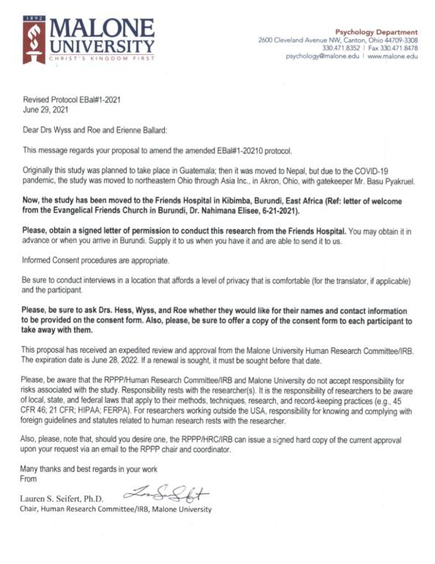
Appendix B
Approval letter from Dr. Nahimana Elisée
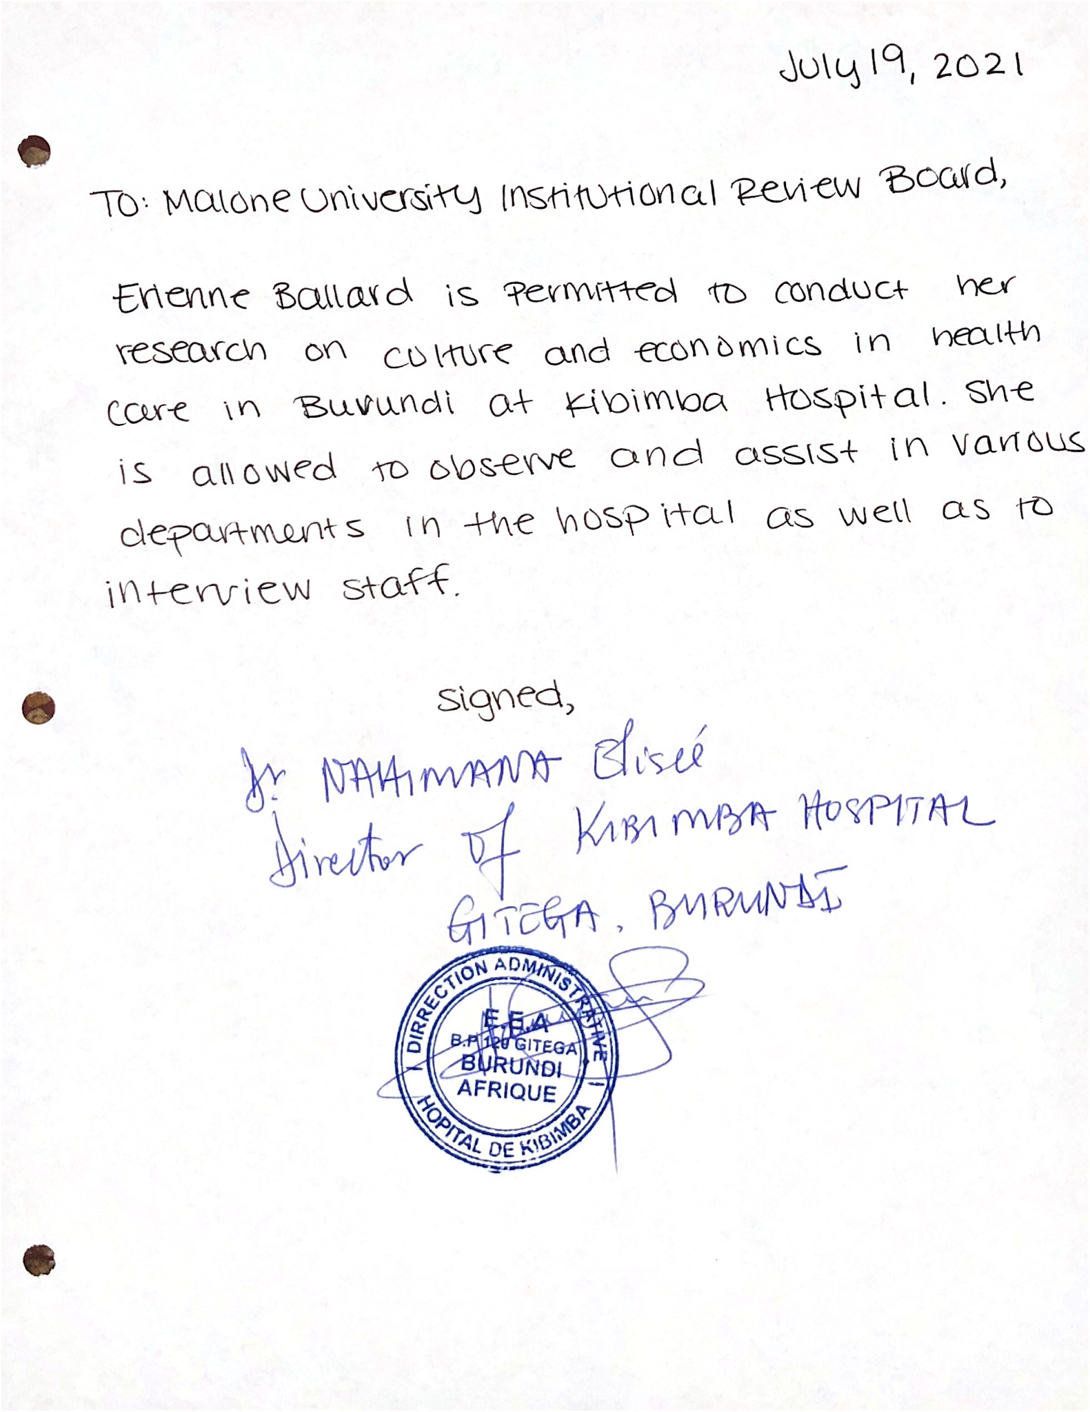
Appendix C
Consent Form - English Version
Burundi Culture in the Healthcare Setting
My name is Erienne Ballard. I am a nursing student at Malone University, Canton, Ohio in the United States. I am here with the Evangelical Friends Mission. As a student who is learning about the importance of cultures and their effect on routines and procedures of nursing in the hospital, I am doing a research study about Burundi culture at Friends Hospital. This study will help me, and other nurses, understand how to work with other cultures for the benefit of the patient. I will do this research by observing and photographing staff and patient interactions at Friends Hospital, and through interviews with staff members.
I would like you to be a part of my project. If you have worked in Burundi health care for more than 6 months, and are on the staff of Friends Hospital during the time I am here, you can agree to be interviewed. I will interview you about typical days, routines, and procedures in the hospital. I will ask you questions about Burundi cultural beliefs and practices that are involved in care scenarios.
To take part in this study I will need to be able to observe your work in the hospital. I will be taking photographs to augment my observations. These photos will not show staff or patients’ faces. Then later, I will interview you at a time conducive to your schedule. I will not interfere with your work or the wellbeing of patients. Staff and patient confidentiality will be respected. You will complete a demographics form. Then I will digitally record our interview if you give permission. I may take notes during and I will transcribe it later. These interviews will be conducted with a translator who is familiar with the hospital.
Your participation in the interview is completely voluntary. I will need around 30 minutes of your time. I may ask you for more than one interview. Your name will not be identified in this study. You may stop participation in this study at any time without penalty.
By signing this consent form, you agree to take part in this research study through an interview. You also agree that you have been given the opportunity to ask questions about this study and that your questions have been satisfactorily answered.

_____________________________________________________ _______________________
Name / Signature Date

Check one option below.
_____ I agree that I can be interviewed and the interview recorded.
_____ I do not want my interview to be recorded, only notes may be taken.

Contact Information of Researcher:
Erienne Ballard
Alliance, Ohio
esballard1@malone.edu

Contact Information of Chairperson, Human Research Committee
Dr. Lauren Seifert
Malone University
2600 Cleveland Ave. NW
Canton, OH 44709
Email address: lseifert@malone.edu

Appendix D
Below is a copy of the French translation of the consent form. This was the version that all participants received and reviewed before they participated in the interviews.
Formulaire de consentement (Consent Form - French Version)
Burundi Culture dans le réglage des soins de santé
Je m'appelle Erienne Ballard. Je suis étudiante en soins infirmiers à l'Université Malone, Canton, Ohio aux États-Unis. Je suis ici avec la mission des amis évangéliques. En tant qu'étudiant qui apprend l'importance des cultures et leur effet sur les routines et les procédures de soins infirmiers à l'hôpital, je fais une étude de recherche sur la culture burundaise à Friends Hospital. Cette étude m'aidera, ainsi que d'autres infirmières, à comprendre comment travailler avec d'autres cultures pour le bien du patient. Je ferai cette recherche en observant et en photographiant les interactions entre le personnel et les patients à Friends Hospital, et en interrogeant les membres du personnel.
J'aimerais que vous fassiez partie de mon projet. Si vous avez travaillé dans les soins de santé au Burundi pendant plus de 6 mois et que vous faites partie du personnel de Friends Hospital pendant le temps que je suis ici, vous pouvez accepter d'être interviewé. Je vais vous interviewer sur les journées typiques, les routines et les procédures à l'hôpital. Je vous poserai des questions sur les croyances et pratiques culturelles burundaises qui sont impliquées dans les scénarios de soins.
Pour participer à cette étude, je devrai pouvoir observer votre travail à l'hôpital. Je prendrai des photos pour compléter mes observations. Ces photos ne montreront pas le visage du personnel ou des patients. Ensuite, je vous interviewerai à un moment propice à votre emploi du temps. Je n'interfère pas avec votre travail ou le bien-être des patients. La confidentialité du personnel et des patients sera respectée. Vous remplirez un formulaire démographique. Ensuite, j'enregistrerai numériquement notre entretien si vous en donnez la permission. Je peux prendre des notes pendant et je les retranscrirai plus tard. Ces entretiens seront menés avec un traducteur connaissant bien l'hôpital.
Votre participation à l'entretien est entièrement volontaire. J'aurai besoin d'environ 30 minutes de votre temps. Je peux vous demander plus d'un entretien. Votre nom ne sera pas identifié dans cette étude. Vous pouvez arrêter de participer à cette étude à tout moment sans pénalité.
En signant ce formulaire de consentement, vous acceptez de participer à cette étude de recherche par le biais d'un entretien. Vous reconnaissez également que vous avez eu la possibilité de poser des questions sur cette étude et que vos questions ont reçu une réponse satisfaisante.

_____________________________________________________ _______________________
Nom/Signature Date

Cochez une option ci-dessous.
_____ J'accepte que je puisse être interviewé et l'interview enregistrée.
_____ Je ne souhaite pas que mon entretien soit enregistré, seules des notes peuvent être prises.

Contact Information of Researcher:
Erienne Ballard
Alliance, Ohio
esballard1@malone.edu

Coordonnées du président, Comité de la recherche humaine
Dr. Lauren Seifert
Malone University
2600 Cleveland Ave. NW
Canton, OH 44709
lseifert@malone.edu
Appendix E
Interview guide.
- Traditionally, how do Burundians care for their sick?
- What illnesses or diseases do Burundians come to the hospital most for?
- Do many people choose to go to traditional healers instead of the hospitals or clinics? If so, can you estimate the percentage of the population that does?
- What is your opinion of traditional medicine?
- Who makes the decision for hospital care?
- What ways does poverty affect patient health?
- What, in your opinion, is the public perspective of Kibimba Hospital?
- At Kibimba, what does maintaining patient privacy look like?
- At Kibimba, what does working as a team look like?
- What does being a nurse mean to you?
  - What does this job represent to you?
- Can you give me a brief description of what your role at the hospital is?
  - What do you do in your department?
- Please rank these by their importance to you or what you think is the most important to focus on: family health, community health, and individual health.
- Each of these nursing values is important to the profession of nursing. Can you put them in the order of what takes priority or is most important to you personally?
  - Trust, nearness, sympathy, support, knowledge, and responsibility.
- From your perspective, what was the impact of COVID-19 on Kibimba? In your department?
- If there is something you could change or improve about nursing/resources/your department/patients, what would it be?
  - Do you think there is a need for additional training or workshops?
- Is there anything else that you would like to tell me about your department, the hospital, or Burundi?
- Do you have any questions for me?

Modified from:
Zoucha, R. D. (1998). The Experiences of Mexican Americans Receiving Professional Nursing Care: An Ethnonursing Study. Journal of Transcultural Nursing, 9(2), 34–44. https://doi.org/10.1177/104365969800900206

Appendix F
Surgical Log
July 21, 2021
- Vasectomy: local anesthetic, Dr. Elisée and the first assist performed surgery. Began with a soap solution to clean the area, followed by milky white substance to clean, followed by iodine. Patient completely exposed until all three had been put on and then was covered with clothes. I was given a mask to wear and shoes for the surgical room but was told I did not have to wash my hands. Two students did not wear a mask. The nurse walked in and out of the room and answered phone texts in the room. Sterile field was barely broken a few times. Only stitches were to tie the vas deferens. No stitches externally as the incisions were small.
- Testicular hydrocephalus.
- External tumor.

July 22, 2021
- Bilateral inguinal cysts: Performed on toddler male. Originally thought to be hernias but upon opening (incision on the muscle line, above the testes, diagonal from midline to lateral) they were found to be cysts. They were removed without any issues. Bandages for all incisions are gauze covered in betadine, another clean gauze, and completed with tape. When the procedure was complete, the assisting doctor took the saline IV bottle and picked the child up and carried him to the recovery room.
- Elbow tumor.
- Left Inguinal Hernia.
- Left Inguinal Hernia.
- Left Inguinal Hernia.
- Right Lateral Tumor, pediatric male.
- Forefinger amputation: 8 or 9-year-old girl with an infected finger. Had had a cut and it had been treated but became gangrenous and when the bandage was taken off, it was coal black and there were stitches around it. She had no feeling in it as Dr. Elisée pinched it to show it. She was super anxious but only cried a little when the medication was pushed through her IV. Prep. First, cut the stitches and then used the scalpel to cake off the first phalange. Used a bone cutter then to take out half of the second.
- Bone necrosis of tibia (osteomyelitis).
- Caesarean section, twins. Baby’s feet came out first and they carried him (boy!) upside down over to the warmer which was not warming. The guy who was caring for the infant dried him and then started suctioning. The second was a girl.
- Debridement of infection in incision: a mom from 3-4 months ago via C-section came in after having infection in her incision. The doctor cut away the dead tissue with the scalpel first and then with scissors. First did the left side of the incision and sewed the fat together and then the skin. Moved to the other half and extended it slightly to get the full amount of dead tissue and same as the first.

July 23, 2021
- Testicular hydrocephalus.
- Skin graft: young adult, male. Prep same, spinal anesthesia. R foot swollen to twice the size of the other. The bottom of the foot had a thick, yellow, and almost crust-like appearance. It looked as though it was cracking and infected. The lateral edge of the foot had a large pink wound. Elisée started by –literally– scraping the top layer with a scalpel. Next, using a tool to scrape the skin from the thigh, in a sawing motion. It took off the very top part of the skin and left it a porcelain white. It soon spotted with blood, but it was torn in places and was not a solid sheet of skin removed and rather appeared as though small strips were taken. Elisée and the assist took the skin from the tool and put it on a sticky mesh square. They straightened/flattened it out, but it kept curling up. Once they situated it, they put it on the wound and then worked on a second patch to finish it up. Finally, covered in betadine and a bandage and wrapped. Elisée said that it would be left on for at least a week before even taking it off to look at. Patient was to remain in the public rooms for observation.
- Genital Necrosis: male, 74. Came in with necrosis/infection of penis and testicles. Once the bandage was removed, it showed necrotic tissue. Elisée reached his hand up towards the stomach and found that the infection and dead skin extended to nearly the umbilicus. The girl anesthesiologist –she was visiting and was looking for a job– and I both expressed our shock. Elisée kept pulling out more and more dead, white, necrotic tissue. During the procedure, there was the use of the hydrogen peroxide to clear the area and a chlorhexidine solution. The chlorhexidine solution was poured on gauze and packed the extended wound into the stomach. They did not stitch him closed.
- Femur fracture: male, about 14.
- Fracture: older woman complained of fracture in leg, but X-ray was clear and showed no break.
- Caesarean section. Observed.
- Caesarean section. Assisted in surgery for the first time.
- Caesarean section. Observed.

July 24, 2021
- Caesarean section. Assisted.

July 29, 2021
- Emergent surgery: a patient who had lower quadrant pain. 2 months pregnant, 38-year-old female. General anesthesia. Exploratory surgery –with me assisting– found a right ovary cyst the size of the uterus. It was dark red, and we removed the whole thing. Suture and check the left for the marble sized one which we were able to take from the ovary rather than the whole thing. Only midline incision from pubic bone to an inch above the umbilicus.

July 30, 2021
Assisted:
- Testicular hydrocele.
- Pediatric inguinal hernia
- Pediatric inguinal hernia
Observed:
- Pediatric inguinal hernia. Observed.
- Pediatric inguinal hernia. Observed.

July 31, 2021
- Fibroma removal: When they opened her up, they didn’t see any signs of fibroma. They worried she was pregnant. They also had accidentally sliced the uterus with the first few cuts because there was a lot of fat to go through. They sent urine from the catheter to the lab to check for pregnancy and paused the surgery. They then began again with a hysterectomy because Elisée thought it might be a molar pregnancy and the result would say positive no matter what. The test came back negative, so they felt better about it. Removed uterus –which was bigger than normal– and tied off the ends. When the surgery was finished, Elisée cut open the uterus and a fetus came out. She was pregnant. I put on the bandage. Apparently, the doctor she came from said it was fibroma and that the scans didn’t show a pregnancy.
- Vasectomy

August 5, 2021
- Left inguinal hernia, male adult. Assist.
- Left neck abscess, female, observe: Finishing the surgery, Elisée left in a chlorhexidine gauze, not closed completely. It wasn’t completely sutured. Prevention for further filling of pus.
- Right inguinal hernia male adult. Assist.
- Left inguinal hernia female peds. Assist.
- Right breast lump female adult. Assist.
- Right side head superficial lump female adult assist: This was not full scrub, just the gloves. I didn’t realize I was assisting until he told me to put the gloves on.
- Prolapsed rectum male adult. Observed.

August 6, 2021
- L knee, synovial cyst, female child. Observed.
- Female pediatric, upper lip cut. Observe. Elisée, the first assistant, and the anesthesiologist. No one in gloves or washed their hands. No sterile field. They were cutting because the lip was too close to the teeth.
- Inguinal hernia left male pediatric patient. Assist.
- Pediatric female, right hand finger correction (middle, ring, and pinky). Assist: he used the cautery. The fingers were kind of webbed to the top of the palm. He cauterized the skin to open it up. I held fingers straight while he tried to decrease the tension by pulling them shut. Sometimes he’d miss and nick a finger, giving it a little burn. By the end of the surgery, there was just open flesh from the palm to the inside of the first knuckle. Some mesh on the hand, betadine and gauze, broken popsicle sticks, and a wrap to complete the surgery.
- Adult female left abdominal recurring tumor. Assist.
- Penile tumor, male pediatric. Assist.
- Lipoma removal on upper right back. Pediatric male. Assist.
- Inguinal hernia, male pediatric. Assist.
- Lipoma removal right shoulder, female 38. Assist.
- Neck tumor female adult. Observe.
- Emergency night surgery– tropical splenectomy. 17, female. Observe.
Patient had come in with recurrent malaria, resulting in tropical splenomegaly.

August 12, 2021
- Left inguinal hernia, male pediatric. Observe.
- Right hernia male adult. Assist.
- Fibroma adult female. Observe.
- Fibroma into hysterectomy, adult female. Observe.
- Left shoulder lipoma, adult female. Assist. Not sterile.
Sometimes the doctor doesn’t scrub in or use alcohol to clean his hands because he’s “lazy sometimes”.
- Right tibial osteomyelitis (originally was only an abscess, female pediatric. Observe. Non Sterile.
- Hysterectomy and ovary removal, adult female. Observe.
- Hysterectomy adult female, elderly. Observe.
- Osteomyelitis of the left hip, female pediatric. Assist.
- Testicular hydrocele, adult male. Assist.
Appendix G
Table 4.1 List of demographics and pseudonyms of the interview participants.
 | 1A | 2B | 3C | 4D | 5E | 6F | 7G
AGE | 48 | 31 | 49 | 26 | 33 | 28 | 35
GENDER | F | F | F | M | M | M | M
NATIONALITY | Burundian | Burundian | Burundian | Burundian | Burundian | Burundian | Burundian
RELIGION | Protestant | Protestant | Protestant | Protestant | Protestant | Protestant | Catholic
DENOMINATION | Evangelical Friends | Evangelical Friends | Pentacostal | Evangelical Friends | Free Methodist | Evangelical Friends | Catholic
PROFESSION | Nurse | Nurse | Nurse | Nurse | Laboratory Tech | Nurse | Nurse
SPECIALTY | Emergency | Pediatrics | Family Planning/ Clinic | Maternity | Laboratory, bacteriology | Surgery | Internal Medicine
MARITAL STATUS | Married | Married | Married | Married | Unknown | Single | Married
TIME IN PROFESSION | 14 years | 7 years | 25 years | 5 years | 6 years | 1 year | 1.5 years
TIME AT KIBIMBA | 14 years | 7 years | 3 years | 5 years | 6 years | 1 year | 1.5 years
EDUCATION | Congo | Moranga | Gitega Nursing School | Moramba University | North Burundi, Ngozi | Kibimba | Gitega Nursing School
PSEUDONYM | Abayomi | Zina | Nayo | Musa | Obike | Ogbonna | Abayomi

 | 8H | 9I | 10J | 11K | 12L | 13M
AGE | 62 | 27 | 33 | 31 | 33 | 39
GENDER | M | F | M | M | M | M
NATIONALITY | Burundian | Burundian | Burundian | Burundian | Burundian | Burundian
RELIGION | Protestant | Protestant | Proestant | Protestant | Protestant | Protestant
DENOMINATION | Evangelical Friends | Evangelical Friends | Evangelical Friends | Evangelical Friends | Evangelical Friends | ERENA Eglise du Revival des Nation
PROFESSION | Doctor | Nurse | Nurse | Doctor | Nurse | Nurse
SPECIALTY | Surgeon | Pharmacy | Emergency –Chief | Consulting/  general | Consulting | Maternity
MARITAL STATUS | Married | Married | Married | Single | Married | Married
TIME IN PROFESSION | 22 years | 5 years | 7 years | 3 years | 2 years | 15 years
TIME AT KIBIMBA | 15 years | 5 years | 7 years | Works in Musama, 25km from Kibimba | 1.25 years | 4 years
EDUCATION | Madagascar, Ivory Coast | Moragna | Bujumbura | AfroAfrican University | Bujumbura | Gitega Nursing School
PSEUDONYM | Enam | Gamba | Halima | Funsani | Hondo | Bour

